# LIBRARY MANAGEMENT SYSTEM WITH BARCODE USER COUNTER IN

# BISU-BILAR

A Thesis

Presented to the Faculty of the

College of Technology and Allied Sciences

BOHOL ISLAND STATE UNIVERSITY

Zamora, Bilar, Bohol

In Partial Fulfilment

Of the Requirement for the Degree

In Bachelor of Science in Computer Science

Teofredo Gamale

Berns Jordan Gerona

Mary Joy Rubas

May 2024

# APPROVAL SHEET

# ACKNOWLEDGEMENT

The researchers wish to express their sincere gratitude, heartfelt praise, and thanksgiving to the Almighty Father for His divine aid and providence, supreme wisdom, unshakeable guidance, and abundant blessings showered upon the researchers in times of endeavors to make the completion of this study.

Sincere thanks and overwhelming gratitude are also extended to the following individuals for the never-ending support, guidance, assistance, and invaluable encouragement in the realization of this work:

**Dr. Proceso M. Castil**, Campus Director, for the approval of the study and for the permission to the researchers to conduct the study;

**Dr. Nelia Q, Catayas**, Dean of the College of Technology and Allied Sciences, for her motherly advice and meaningful remarks;

**Mr. Joel A. Piollo**, Chairperson of the Department of Computer Science, for his enrichment, for his inspiring and helpful words;

**Mr. Darrel A. Cardaña and Ms. Leonida P. Revilla** for their valuable suggestion, guidance and for supporting the researchers along the way;

**Engr. Max Angelo D. Perin**, Thesis Expert, for his brilliant and amicable mentoring, valuable inspiration, encouragement, and sincere guidance that helped much in the realization of the study;

**Mr. Rex Vincent D. Tejada**, Thesis Adviser, for his incredible insights, encouragement, and belief to the best of what the researchers can do;

**Ms. Maricel L. Maalihan** English Critic, for helping the researchers in the manuscript in terms of enhancement and progress of the study.

To the Faculty Association Unit, BISU Staff who spent their time answering the questionnaires;

**Ms. Ma. Geraldine M. Merlas**, School Librarian, for serving and allowing the researchers to avail themselves of the valuable books, materials, and references relevant to the study.

To the parents of the researchers, who were very supportive financially, physically, emotionally, spiritually and morally;

To all those who have been part of realizing this work, the researchers deeply appreciate them all.

**The Researchers**

# ABSTRACT

The study's primary purpose is to develop a “Library Management System with Barcode User Counter in BISU-Bilar,” located at Zamora, Bilar, Bohol. An essential improvement in how libraries run and manage their resources is a library Management System with a Barcode User Counter. This system combines contemporary technology features with the functionality of conventional library management, especially barcode technology for tracking and identification. It can track user interactions with library resources in real time. Every time a user borrows or returns a book, the system records the transaction, allowing librarians to maintain an accurate inventory and track the popularity of different materials. Bohol Island State University-Bilar Campus still uses manual operations to record attendance and library management. The analysis and development of the system are guided by analyzing the school's existing operations and procedures. The study finds that the present system encountered problems such as difficulty in recording attendance, tallying books borrowed, inventory of students who enter the library, monthly unsafe data where data is written and stored in folders, and limited coverage of advertisement and promotion. The system was developed with the following modules: attendance through a Barcode scanner, monitoring, administration, and reporting. A standard system usability questionnaire was used for evaluation during the testing and implementation. The result gave positive feedback as the system had improved the ordering and distribution management efficiency, the recording and tallying of votes, as well as the requirements and expectations of the client. Based on the evaluation result, the respondent or the users find the rate of 4.52 or an " Agree” rating to the system, indicating the achievement of individual expectations, particularly on features such as ease of use, visual clarity, language, and its application in general. Thus, implementing the Library Management System with a Barcode User Counter in BISU-Bilar is highly recommended.

Keywords: Student Attendance Monitoring, Barcode System, Bohol Island State University-Bilar, Standard Web Usability.

**TABLE OF CONTENTS**

**page**

TITLE PAGE …………………………………………………………………………….i

APPROVAL SHEET ………………………………………………………………......ii

ACKNOWLEDGEMENT ……………………………………………………………...iii

ABSTRACT ……………………………………………………………………………..v

LIST OF TABLE ……………………………………………………………………….ix

LIST OF FIGURES ……………………………………………………………………..x

**LIST OF PREVIEWS** …………………………………………………………………………

**Chapter**  1  **THE PROBLEM AND ITS SCOPE**

Rationale ……………………………………………………………………….**1**

Literature Background **4**

Statement of the Problem **11**

Objectives of the Study **11**

Scope and Limitation of the Study **12**

Significance of the study **13**

**RESEARCH METHODOLOGY**

Developmental Framework **14**

Development Models and Approaches **15**

Environment and Participants **18**

Data Collection **18**

Operational Definition of Terms **20**

**2 PRESENTATION OF FINDINGS, ANALYSIS AND INTERPRETATION OF DATA**

Existing Operations and Processes **21**

Event Specification ………………………………………………………………..**21**

Needs of the Present System **25**

Use Case Diagram **29**

Use Case Narrative **31**

Database Design **33**

Class Diagram **35**

Program Hierarchy **40**

Functional Requirements **41**

Non-Functional Requirements **43**

Test Case **43**

Technical Requirements **50**

Minimum Hardware Specification **51**

Minimum Software Specification **51**

Screen Layout **52**

Economic Economic Performance Evaluation **59**

Testing and Evaluation **60**

System Usability **60**

Summary of Findings **62**

Conclusion **63**

Recommendation **63**

**REFERENCES** **65**

**APPENDICES** …………………………………………………………………………

A. Letter of Intent ……………………………………………………………...**67**

B. Guide Questions for the interview ………………………………………..**69**

C. Letter of Implememtation …………………………………………………**70**

D. Documentations …………………………………………………………. **71**

E. Usability Questionnaire………………………………………………........**72**

F. User’s Manual ………………………………………………………………**75**

G. Source Code………………………………………………………………..**80**

**DEVELOPER’S BIO DATA** ………………………………………………………... **82**

# LIST OF TABLES

**Table page**

1 Distribution of respondents in the system usability assessment …………**17**

2 Interpretation Guide of the System Usability…………………………………**18**

3 Use Case Narrative - Students Data Record **31**

4 Use Case Narrative - Attendance **32**

5 Use Case Narrative – Transaction **32**

6 Use Case Narrative – Reports **33**

7 Database Structure used for Admin Data for Login **36**

8 Database Structure used for Student Data **36**

9 Database Structure used for Staff Data for Login **37**

10 Database Structure used for Student Barcode Attendance Data **37**

11 Database Structure used for Student Attendance Log in Data **38**

12 Database Structure used for Books Data **38**

13 Database Structure used for Student Borrowing Books Data **39**

14 Database Structure used for Student Returning Books Data **39**

15 Minimum Android Hardware Specification …………………………………..**49**

16 Minimum Android Software Specifications **52**

17  Economic Initial Investment **59**

# LIST OF FIGURES

**Figure page**

1 Conceptual Diagram of the Study ……………………………………………**18**

2 Block Diagram of the Proposed System……………………………………..**19**

3 Rapid Application Development Diagram …………………………………..**31**

4 Conceptual Diagram of the Present System ………………………………...**32**

5 Record Students Data(Event1) ……………………………………………….**33**

6 Student Attendance(Event2) ………………………………………………….**33**

7 Faculty/Visitor Attendance …………………………………………………….**36**

8 Record of Faculty/Visitor Data ………………………………………………..**36**

9 Transaction (Event 3) ………………………………………………………….**37**

10 Reports (Event 4) ………………………………………………………….…**37**

11 Top Level of the Present System …………………………………………….**38**

12 Use Cases Diagram ……………………………………………………………**38**

13 Class Diagram ………………………………………………………………….**39**

14 Program Hierarchy ………………………………………………………….…**.39**

**LIST OF PREVIEWS**

**Preview page**

1 Admin Login ………………………………………………..…………………**52**

2 Home Page ………………………………………….………………………..**53**

3 Users for Admin Management ………………………………………………**53**

4 User for staff ……..……………………………………………………………**54**

5 For Faculty/Visitor Management ……………………………………………**54**

6 Dashboard …………………………………………………………………….**55**

7 Reports …………………………………………………………….…………..**55**

8 Students Attendance ……………………………………..………………….**56**

9 Books Transaction ……………………………………..…………………….**56**

10 Report for attendance per month …………………………………………...**57**

11 Book Management …………………………………………………………...**57**

12 Book Transaction for Borrowing ………………………………………….…**58**

13 Book Transaction for Returning……………………………………………..**58**

14 Penalty Data ………………….………………………………………………**59**

**Chapter 1**

**THE PROBLEM AND ITS SCOPE**

### Rationale

Computerized applications enable people to connect with excitement and create a working environment where time is utilized productively. This computer application provides user interaction and overcoming disadvantages such as manual recording mistakes and records retrieval delay (Sabado et al., 2015). Most academic institutions have adopted several computer applications for instruction, research, and extension activities.

Bohol Island State University-Bilar Campus is a public institution located at Zamora, Bilar, Bohol that operates the public library. Currently, the method of managing records of library materials and borrowers’ information, including its processes such as borrowing, returning, and reserving books, is done manually. This method led to the difficulty in researching library materials, retrieval of borrower’s information, duplication of borrower’s card, and loss of borrower’s information sheet.

With the problems encountered, the developers identified solutions for enhancement of the existing management of library materials, notably record recording, borrowing, reservation, and returning library materials. Moreover, it was determined that ease of access to references such as books, traceability of instructional resources, ease of updating books, generation of reports in tabular or graphical format, generation format, generation of borrower’s profile, and secure records of reference materials are the needs of the establishment to improve the management or operation. Thus, the Library Management System with Barcode User Counter in BISU-Bilar.

A barcode user counter has numerous advantages. It primarily gives libraries real-time information on the number of visitors, the length of their stays, and the particular resources or services they use. This information can help personnel, purchase resources, and create user-specific library programs and services. The method also improves security by assisting librarians in keeping track of material movement and preventing theft or unlawful borrowing. Additionally, it can help with contact tracking during public health emergencies, safeguarding the security of library patrons and employees. The Barcode User Counter makes it easier to authenticate library users for various services. This streamlined authentication process enhances user convenience and reduces the need for manual intervention.

Human headcounts and paper sign-in sheets were employed to track library usage in the past. These techniques do not offer real-time insights, are time-consuming, and are subject to human error. The Barcode User Counter, on the other hand, provides a cutting-edge and effective solution that uses technology to track library users and their activities precisely. Barcode technology, commonly used in libraries for organizing collections and streamlining patron interactions, is a critical component of this integrated system. Individual barcode-enabled cards or mobile apps are given out to library patrons as means of identification. At predetermined checkpoints, such as entrances and service desks, patrons scan their barcodes as they enter and leave the library. After that, the system logs this data, leaving a digital trail of user activity. This promoted the researchers to conduct that would benefit the school.

### Literature Background

Based on the Republic Act No.7687, Section 2 of the Philippine Construction, which states that:

*“This statement highlights the significance of science and technology for a country's progress. It stresses that the government should prioritize using and advancing science and technology, focusing on innovation and research. The strategy aims to grow the science and technology workforce in line with economic development. To achieve this, the government promises to assist talented individuals and science students in pursuing higher education or training in science and technology by offering grants, scholarships, or other financial aid.”*

The study of the Library Management System with a Barcode User Counter in BISU-Bilar is a part of the broader research on the use and effectiveness of barcode technology in libraries. Barcode technology has been widely adopted in various industries, including libraries, due to its efficiency in tracking and managing resources. This study specifically focuses on integrating a barcode-based user counter with the library system to improve the understanding of user behavior and enhance library services.

According to this article Barcode User Counter0, this study builds on prior research. It aims to better understand library user behavior by integrating a barcode user counter with the library system. Barcode systems have been used for library automation, streamlining processes, and decreasing time consumption in tracking and processing goods. Integrating a barcode user counter with the library system can provide insights into user preferences, resource usage, and general library efficiency. The user experience can be improved overall, and library services can be optimized. Resource allocation can also be improved. The study is anticipated to support ongoing initiatives to update and enhance library services through technology.

The study builds upon the existing knowledge of the benefits of barcode technology in libraries, including automation, streamlining processes, and reducing time consumption in tracking and processing goods. Integrating a barcode-based user counter with the library system can provide valuable insights into user behavior, resource utilization, and overall library performance. This information can be used to optimize library services, improve resource allocation, and enhance the overall user experience. The study is expected to contribute to the ongoing efforts in leveraging technology to transform and modernize library services.

Within educational institutions, libraries are essential for stimulating academic research, fostering learning, and providing access to knowledge. As technology develops, libraries progressively implement cutting-edge programs and equipment to improve their offerings and productivity. In this regard, a cutting-edge strategy to reinvent the conventional library experience is the Library Management System with a Barcode user counter in BISU-Bilar.

BISU-Bilar, a leading educational institution, recognizes the importance of its library as a valuable resource for students, faculty, and researchers. Over the years, the library has grown in size and scope, catering to a diverse community

with varied information needs. Ensuring efficient library operations and optimizing resource allocation have become critical concerns for BISU-Bilar, prompting a need for innovative solutions.

The traditional method of manually recording visitor statistics and resource utilization has proven inefficient, labor-intensive, and prone to errors. Accurate data on library usage is essential for informed decision-making, such as adjusting library hours, optimizing the allocation of resources, and tailoring library services to user needs. Consequently, there is a growing demand for a more sophisticated and automated approach to library management and user tracking.

Barcode technology, known for its speed and accuracy in data capture, has been successfully employed in various industries. The library management system with a barcode user counter in BISU-Bilar can potentially revolutionize library operations. By automatically tracking user entries and exits, this technology promises to provide real-time, precise, and comprehensive data on library usage patterns. A Library Management System with a Barcode User Counter in BISU-Bilar will be used in this project to look into its design, implementation, and evaluation. Through a thorough analysis of this integration, it aims to offer insights into its impact on library effectiveness, resource management, and user happiness. By bringing library systems and services into line with the requirements of a contemporary educational institution, this research aids in the continual evolution of libraries.

Jeevan (2000) explained the application of barcodes in the IIT Kharagpur library highlighted its future applications. Islam and Shuva (2010) explore a survey of overall barcode technology, its uses, applications, merits, and demerits in the eight libraries in Dhaka. Tella (2010) elaborates on the library activities where barcoding is applied to achieve greater efficiency and accuracy. Accession, Membership, Circulation, and Stock Verification are the thrust areas for barcode application in the library. Rijal (2011) showed that the barcode bridges the users and the libraries. He also found in his research that only a limited number of libraries used barcode technology. This limit is due to the need for a proper budget and computer infrastructure. Also, it is recommended that the appropriate implementation of barcode technology take place with suitable barcode systems, better-quality scanning devices, and advanced software. Rahaman (2016) explained the application of three modern technology initiatives.

These are becoming beneficial technology not only to serve the users but for library security also. Fatima and Ansari (2017) tried to assess the impact of barcode technology in the seminar library. They pointed out that the users of the seminar library have benefitted from the application of barcode technology. Barcode technology has helped particularly in circulation and stock take process, and it is cheaper and integrated with prominent library automation software packages. Chanda (2019) discusses the application of barcode technology in libraries, its working mechanism, and the advantages and disadvantages of this technology. The paper also discusses the creation of Barcode with Glabels opensource software, which is free of cost. The literature review shows that Barcode is a very cost-effective technology that every library can use.

This study intends to provide a thorough understanding of the benefits, difficulties, and implications of the Library Management System with Barcode User Counter in BISU-Bilar by addressing these objectives. The research's conclusions and suggestions are meant to help the library and other educational institutions think about making comparable improvements to their library systems. Ultimately, this study helps the library's continued evolution, matching its operations and services with the changing demands of BISU-Bilar's academic community.

Some existing related systems can be utilized as a reference. Among the significant studies for system development are:

Barcode-Based Student Attendance System by K. Lakshmi Sudha et al. (2015). The system is software that utilizes a barcode scanner to record and maintain the students' attendance. The leading hardware to be used is the barcode scanner. This barcode scanner is used to read a barcode. A barcode consists of parallel, adjacent bars and spaces.

Attendance Management System Using Barcode. A system that takes down student’s attendance using a barcode provides every student with a card containing a unique barcode. Each barcode represents a unique student ID. Students have to scan their cards using a barcode scanner, and the system notes their attendance as per dates. The system then stores all the student’s attendance records and generates a defaulter list. (Vishwakarma Dharmesh et al., 2019).

Using Barcode to Track Student Attendance and Assets in Higher Education Institutions by Salah Elaskari et al. (2002). This study aims to track student attendance and assets, two critical problems in most universities since these are parts of the student evaluation process and annual audits for university assets. While there are many methods in the literature to solve the problem of student and asset tracking, the researchers chose barcode technology because it is cheap and easy to implement. In this paper, the researchers start with a historical overview of the beginning of the use of barcode technology and identify some of its types. Bernard Silver and Norman Joseph Woodland invented the first optically scanned barcode and introduced the first-ever barcode, which looks like a bullseye. In 1952, they developed the barcode, reduced the cost of the system, and registered a patent. Later, they developed solutions to automatically read product information during grocery checkout for the food chain Food Fair. Since then, the barcode project has widely spread.

Attendance Management System Using Barcode Identification On Identity Crads by Y.K.Saheed et al.,(2016). This proposed study is for all organizations, whether commercial or educational, to maintain a proper record of the attendance of their employees or students for effective functioning, planning, and management of the organization. In most academic institutions in developing countries, attendance is usually taken manually using paper sheets and the old file system approach by calling students' names. According to (Tabassam et al., 2009), it becomes cumbersome for the management to regularly update the records and manually calculate the percentage of classes attended for examinations and subsequent results processing. Lack of adequate attendance record keeping has degenerated to a greater level, especially in Nigerian institutions.

Faculty Attendance Monitoring System: An improved feature with Barcode Scanner by Allen James Gomez et al.,(2015). This study aimed to design and develop a barcode-based faculty attendance system for Capitol University using the System Development Life Cycle, specifically the Waterfall Model, as a framework. The system's development was geared toward improving the school’s faculty attendance monitoring, making it efficient in terms of time, recording, and coverage.

The library management system by Shubham Zunjar et al. (2020) aims to develop and automate various tasks involved in managing a library's daily operations. Unlike traditional systems, it offers unique features such as a user login for students and teachers and an admin login for system monitoring. Additionally, it provides an online notice board where users can share information about workshops or seminars, subject to verification by the librarian. Students can conveniently view their issued books, along with their issue and return dates, and even request the addition of new books through a dedicated form. For the librarian, the system can generate various reports, including those for students, issues, teachers, and books. Ultimately, this project is designed to enhance efficiency, reduce manual efforts, and improve overall library management for students and staff.

**THE PROBLEM**

### Statement of the Problem

The study aimed to develop a Library Management System with a Barcode User Counter in BISU-Bilar. Specifically, the study sought answer the following questions:

1. What is the current process for the BISU-Bilar Library?
2. What are the problems encountered in monitoring attendance and circulation of books in BISU-Bilar Library?
3. What features are to be developed to enhance the current process in BISU-Bilar?
4. What is the level of System Sustainability as perceived by the target users?

### Objectives of the Study

The main objective is to design and develop a Library Management System with a Barcode user counter in BISU-Bilar Specifically;

1. Computerized the students attendance and recording of the books to prevent losing and misplacement.
2. Ease of access by prospective students for book checkouts and returns of books.
3. Enhance attendance by using a barcode scanner. This involves upgrading the scanning technology and ensuring compatibility with diverse barcode formats.
4. Instead of listing, the database should be used to appropriately fill out the documents and files.
5. A fast processing in retrieving and storing data.

### Scope and Limitation of the Study

The study focused on the Library Management System with Barcode User Counter on the BISU-Bilar Campus the development of the proposed system covered only the following process.

**Borrowing/Return.** The system would provide the management for borrowing/returning damaged and lost books/library materials.

**Recording.** This module includes recording or updating the old or new data of the students who borrowed books and entered the library within a month. This system also provides information for updating, deleting, and searching.

**Reports.** It involve data collecting, such as attendance, borrowing books, and inventory of the students who visit the library. It will offer reports ready for printing in tabular formats, such as students’ daily attendance.

The scope of this study is defined by its focus on the Library Management System with a Barcode user counter within the context of BISU-Bilar's library. The study encompasses various aspects related to the integration, its implications, and its impact on library operations and user experience.

### Significance of the study

The development of the Library Management System with a Barcode user counter in BISU-Bilar holds profound significance and implications for various stakeholders, including the library administration, staff, patrons, and the broader academic community.

**Librarian.** The librarian is the one who would manage the circulation of the library. The designed system would help the librarian quickly to get the numbers of visitors, monthly and inventory reports, and provide secure records about the books/library materials and borrowers' information.

**Staff**. It would be easier for the staff to retrieve the records, and the work would be minimized. It would increase the morale of the staff using the computerized system since it reflects technological advancements implemented by the students. The staff would also be responsible for entertaining the students to borrow and check the book availability.

**Library Users.** Library users can experience the most convenient service through fast and accurate record retrieval in time. The designed system would simplify the recording of information on library materials. It would lessen the time spent retrieving information from books.

**Researchers.** The study would enhance their skills and knowledge in advanced technology by developing a system and becoming more aware of the existence and benefits of new technology.

### RESEARCH METHODOLOGY

It is a procedure, technique, and set of rules that analyze the principles that guide inquiry in a particular field. It gives more knowledge to understand the flow of the logic.

### Developmental Framework

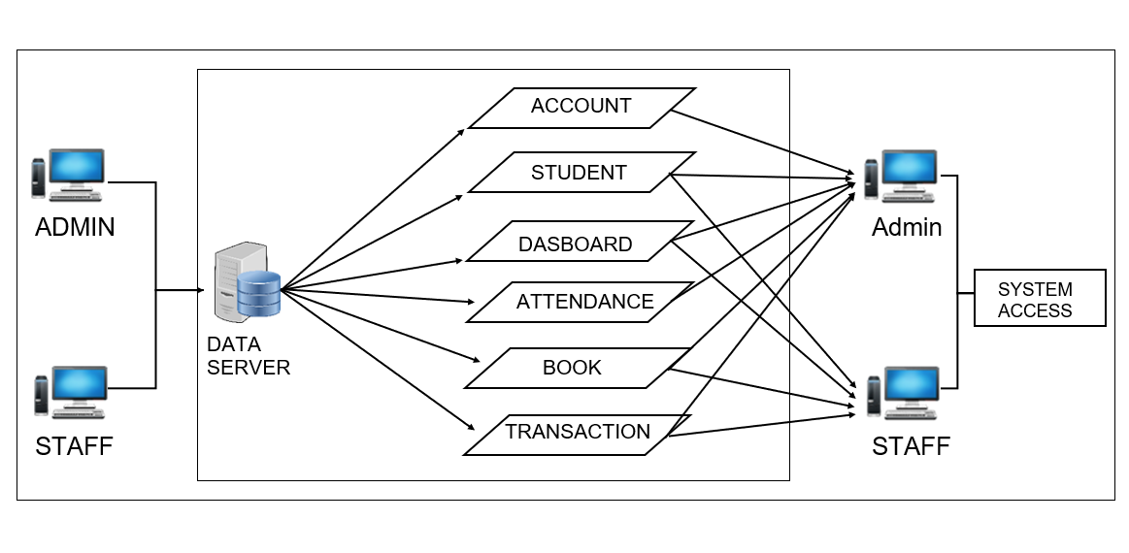

### Figure 1. Conceptual Diagram of the Study

Figure 1 shows the conceptual diagram of the study. It represents the study model that follows the principle of input-process-output. These inputs come from the librarian and students. The process includes the accounts, dashboard, attendance, book, transaction, records, and log-in. The output provides the system access. It would also represent the work of the admin/staff of the Library Management System with a Barcode User Counter in BISU-Bilar.

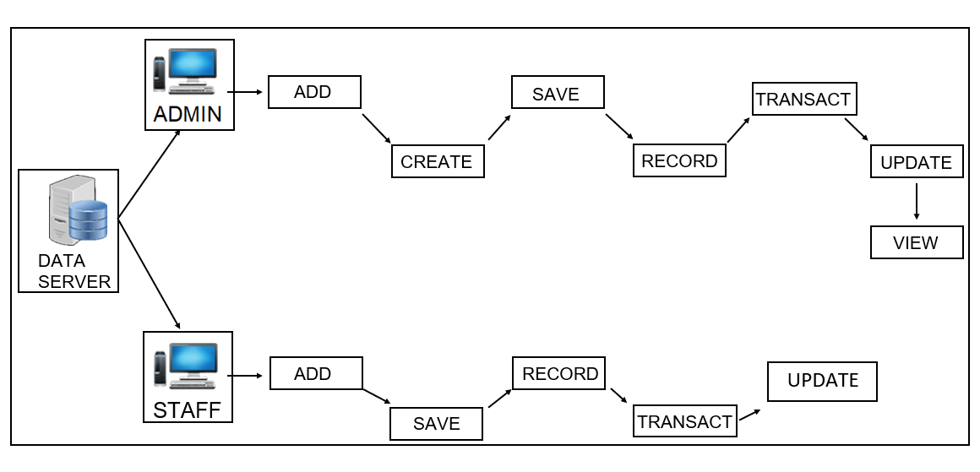

### Figure 2. Block Diagram of the Proposed System

Figure 2 shows the block diagram of the proposed electronic point of the BISU-Bilar library. It includes the specifications for the system’s essential features, which include the entities, functions, input, and intended outputs. It also comprises the functions that carry out the system’s day-to-day operations.

### Development Models and Approaches

In designing the software, developers used the Rapid Application Development model to develop the Library Management System with a Barcode User Counter in BISU-Bilar. In the rapid application development model, prototypes are churned out and delivered to the client for feedback on future prototypes, where new functions are added.

The prototyping methodology performed the analysis, de and to sign, and implementation phases, and all three phases were performed repeatedly in a cycle until the system was completed. Developers built a prototype from the given quick design. The prototype was handed to the user for testing and to provide comments for repeat analysis and design until a second prototype was developed. The process continues in a cycle until the user and the developer agree to a final system.

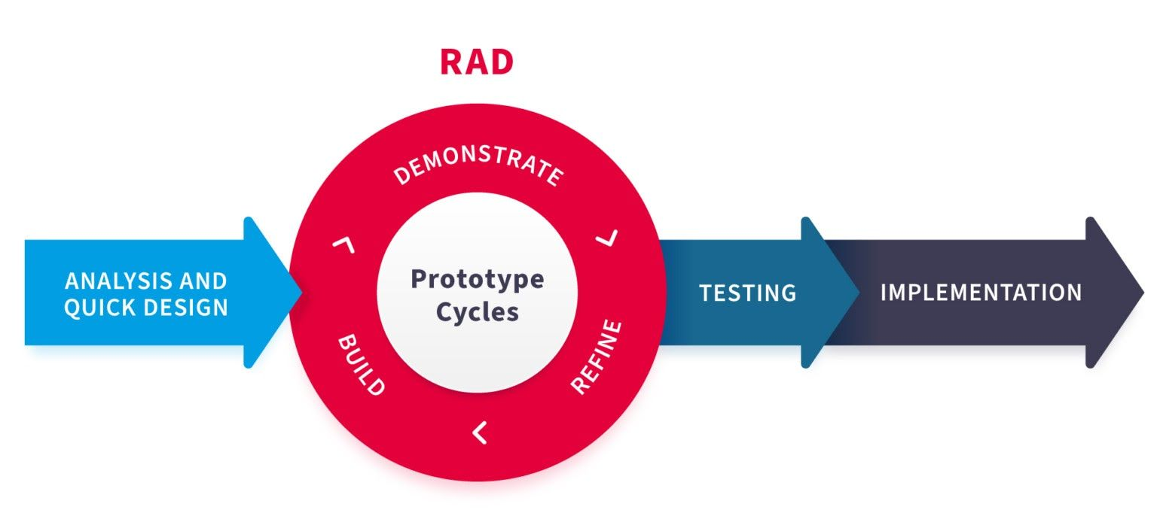

### Figure 3. Rapid Application Development (RAD) Diagram

### Figure 3 shows the Rapid Application Development (RAD) Diagram. The software was designed, and developers used the Rapid Application Development model to develop the Library Management System with a Barcode User Counter in BISU-Bilar.

Technological tools are used in designing the Library Management System with a Barcode User Counter in BISU-Bilar.

* **Visual Studio -** is a programming language suitable for library management systems with a barcode user counter in BISU-Bilar. It isused to create websites, web applications, web services, and mobile applications. It is a powerful tool with great debugging and editing experience.
* **Database-** is a database management system. To collect data in the Barcode-Based User Counter Integrated with the Library System in Bisu-Bilar, an organized collection of data or a type of data store based on the use of a database management system, the software that interacts with end users, applications, and the database itself to capture and analyze the data.
* **Wamp Server -** This is used for the Library Management System with a Barcode User Counter in BISU-Bilar. A local host or server tests clients or websites before publishing them to a remote web server. A WAMP server is the central hub that helps manage and coordinate information in the Library Management System with the Barcode User Counter in BISU-Bilar. It acts as the central system, allowing users to access, track, and process library data efficiently through barcodes and ensuring the smooth functioning of the user counter system at the library.
* **PHP-** an open-source, server-side programming language that can create websites, applications, customer relationship management systems, and more.

### Environment and Participants

The study was conducted at the BISU-Bilar Library Campus at Zamora, Bilar, Bohol. The study's respondents are the library staff, teachers, employees, visitors, students, and librarians. The librarian and library staff handle the student library management system. To track and manage library user traffic and to enhance the library user counter.

### Data Collection

The study initiated by the researchers began with a formal letter requesting permission from the BISU-Bilar librarian. After that, they conducted face-to-face interviews with the librarian using a set of planned questions to gain insights into the current operational procedures at BISU-Bilar Library. The information obtained from these interviews was carefully documented. In addition to interviews, the researchers also undertook a thorough review of various documents. This included examining records such as entering the library using a barcode and borrowing books, which is essential for inputting data into the data design.

The Department of Computer Science is our respondents who rated the system usability assessment, such as (3) Faculty and (26) Students. Table 1 below presents the summary of respondents involved in the process.

### Table 1. Distribution of respondents in the system usability assessment

|  |  |
| --- | --- |
| **Respondents** | **Frequency** |
| Faculty  Students | 4  26 |
| **Total** | 30 |

Table 2 shows the interpretative guide for rating the system usability questionnaire’s individual items.

### Table 2. Interpretation Guide of the System Usability

|  |  |  |  |
| --- | --- | --- | --- |
| **Weight** | **Range** | **Description** | **Interpretation** |
| 5 | 4.6 – 5.0 | Strong Agree | The respondents strongly believe and are confident that the System is very  usable. |
| 4 | 3.7 – 4.5 | Agree | The respondents tend to believe that the system is  usable. |
| 3 | 2.8 – 3.6 | Neither Agree nor  Disagree | The respondents are neutral in  trusting that the system was usable. |
| 2 | 1.9 -2.7 | Tend to Disagree | The respondents tend not to  trust that the system is usable. |
| 1 | 1.0 – 1.8 | Strongly Disagree | The respondents strongly believe that the system is not  usable. |

To determine the acceptability of the system, the weighted mean score was computed to evaluate the system usability level using the following formula:

**1 f 1 + 2 f 2 + 3 f 3 +**

**WMS 4 f 4 + 5 f 5**

**n**

Where: =

WMS = Weighted Mean Score

f1 = frequency of respondents who give a rate of 1

f2 = frequency of respondents who give a rate of 2

f3 = frequency of respondents who give a rate of 3

f4 = frequency of respondents who give a rate of 4

f5 = frequency of respondents who give a rate of 5 n = number of respondents 1,2…5= constant(rating)

### OPERATIONAL DEFINITION OF TERMS

To have a better understanding of the study, the following terms were operationally defined:

**Administration.** It is a module that handles the confidentiality of the system's records. It is used for the privileges and security of the librarian and staff when logging on to the system and for the maintenance of the system.

**Borrower.** Refers to the library's users, including the school's students and the faculty.

**Barcode Scanner.** It is an electronic device for reading printed barcodes. It isused to capture and read students' information in a barcode.

**BISU-Bilar.** The school where the researchers conducted the study.

**Library Student Record Management System.** It is a developed system that will be implemented at Bohol Island State University-Bilar of Zamora, Bilar, Bohol.

**Librarian.** The person who has the authority to access the whole system.

**Library.** Refers to the library of BISU-Bilar.

**Reports.** This is the summary of all the system events.

**System.** This refers to the library management system with a barcode user counter that the developers developed in BISU-Bilar.

**Chapter 2**

**PRESENTATIONS OF FINDINGS, ANALYSIS, AND INTERPRETATION OF DATA**

### Existing Operations and Processes

The BISU-Bilar Library still uses manual processes to process the library management system, and the students manually write details like information. The school Librarian manually monitors the status of the number of students who enter the library and manages the library. The staff will assist the students who borrowed books.

1. **Attendance**

Students enter the library and write their information manually.

1. **Borrow book**

The admin or staff manually records the student's borrowing information in paper borrowing format.

1. **Return book**

The admin or staff manually checks the records of borrowed books listed in papers for returning transactions.

1. **Reports**

The admin staff manually counts all the total data being recorded.

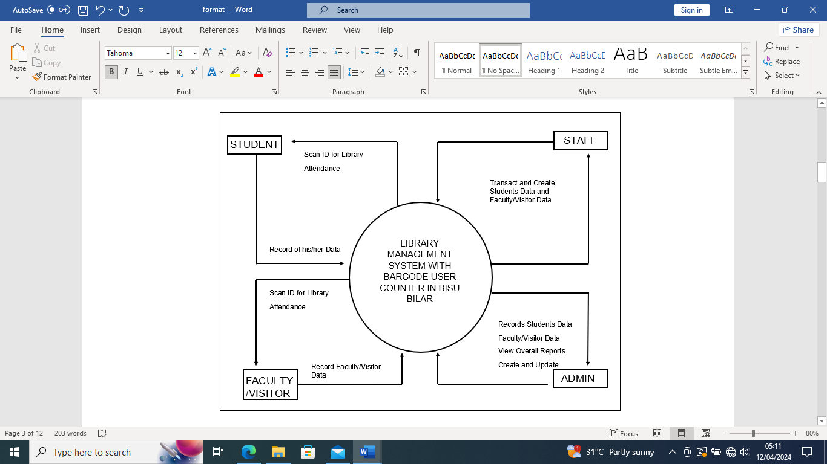 The Library Management System with Barcode User Counter in BISU-Bilar involves scanning library materials using barcodes to record borrowing activities, updating the database with user details and due dates, and enabling efficient management and tracking of library resources. This transaction initiates the lending process, allowing users to borrow items while maintaining an accurate inventory of available materials within the library system at BISU-Bilar.

### 

LIBRARY MANAGEMENT SYSTEM WITH BARCODE USER COUNTER IN BISU-BILAR

### Figure 4. Conceptual Diagram of the Present System

**Event Specifications**

1. Record Students Data
2. Student Attendance
3. Faculty/Visitor Attendance
4. Records of Faculty/Visitor Data
5. Transaction
6. 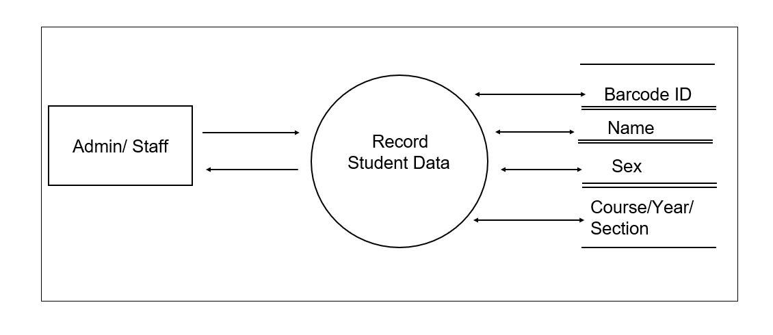View Report

### Figure 5. Record Student Data (Event 1)

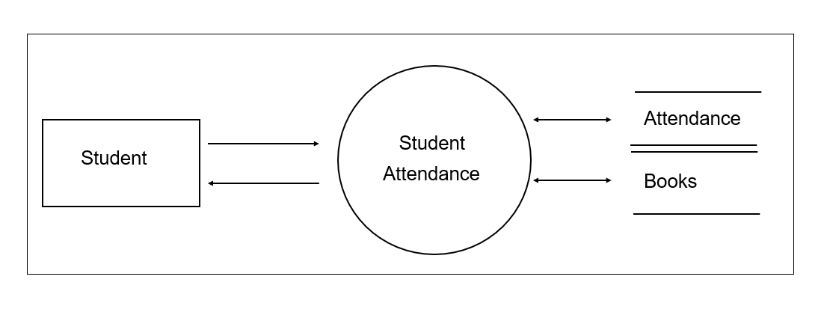

### 

### Figure 6. Student Attendance (Event 2)

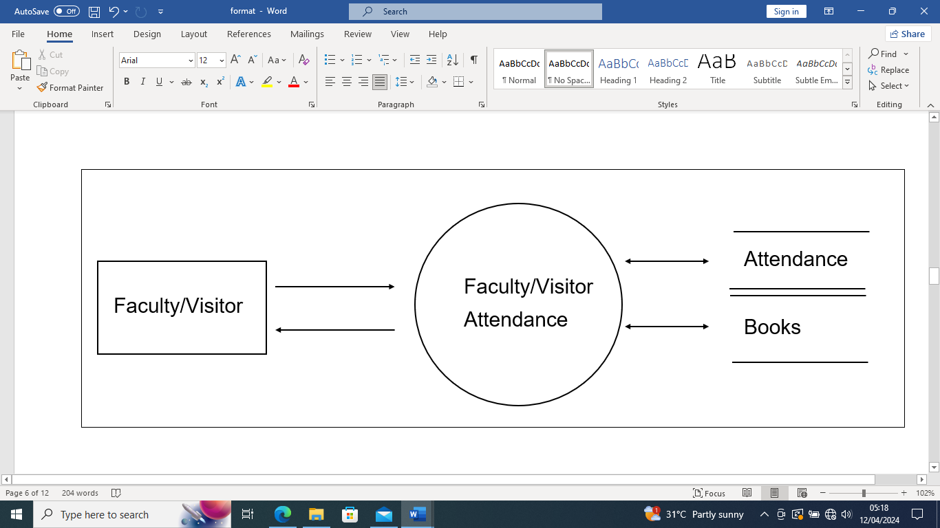

### Figure 7. Faculty/Visitor Attendance

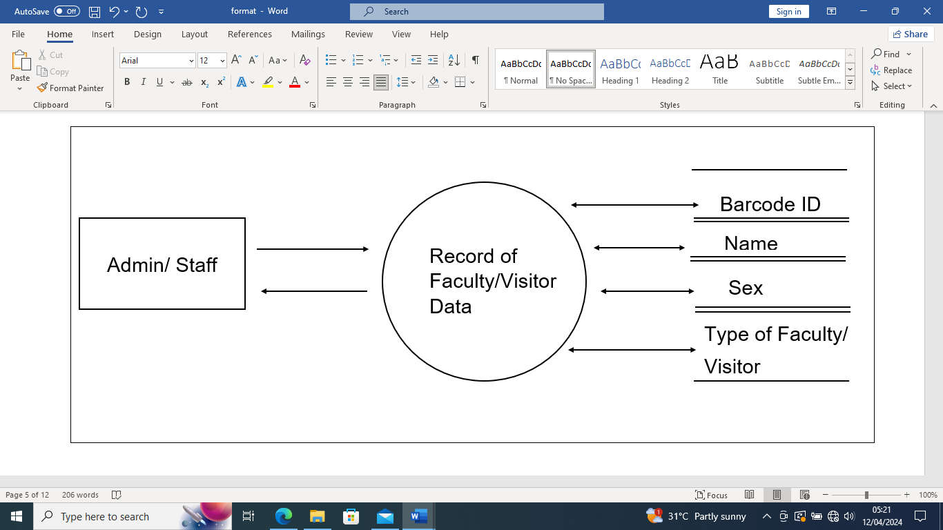

### Figure 8. Record of Faculty/Visitor Data

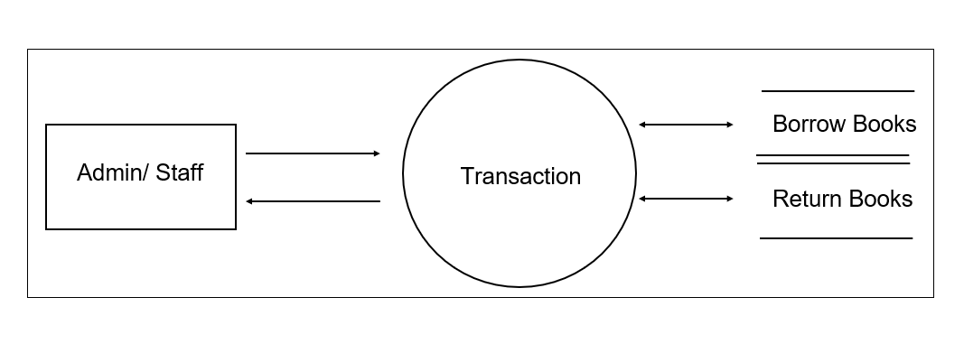

### Figure 9. Transaction (Event 3)

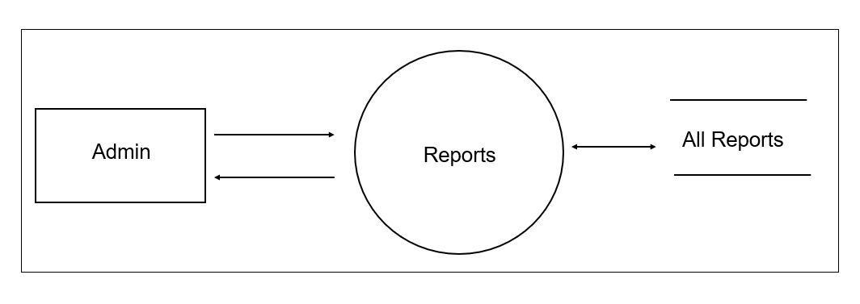

### Figure 10. Reports (Event 4)

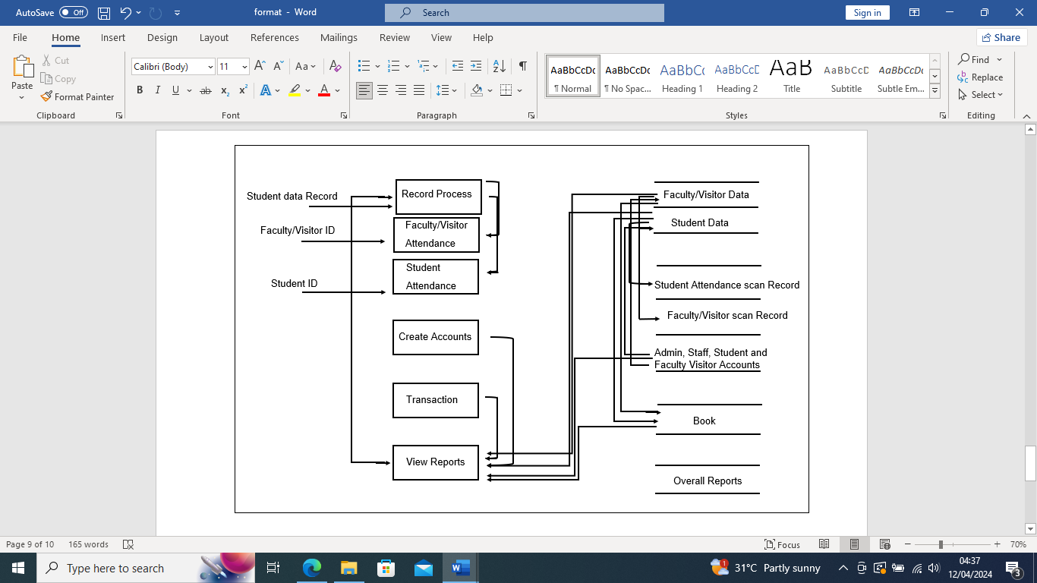

**Figure 11. Top Level of the Present System**

### Needs of the Present System

The present system still uses the manual method, and it needs to be improved. Based on the researchers’s observations, they found the following needs.

1. Computerize the students' attendance and record the books to prevent loss and misplacement.
2. Utilizing barcode user counters allows for tracking real-time data on library usage, providing valuable insights into visitor trends, popular materials, and peak hours. This data informs strategic decision-making and resource allocation.
3. Ensure ease of access for prospective students to check out and return books.
4. Enhance the efficiency and accuracy of barcode scanning by upgrading the scanning technology and ensuring compatibility with diverse barcode formats.
5. Replace files and folders with a database to organize documents and files properly.
6. Ensure fast processing in retrieving and storing data.

**Developed System: Library Management System with Barcode User Counter in BISU-Bilar**

Based on the information gathered from the present system, the researchers came up with the proposed Library Management System with a Barcode User Counter in BISU-Bilar, which covers the Accounts, Dahboards, Students I.D, Incrementing Counter, Data Logging, and Transactions of the students. The system aims to provide a convenient and efficient process for the Barcode User counter as well as the storage and retrieval of data. The system can be accessed only by authorized personnel with the skills and the ability to manipulate the system.

1. **Record Process**

The recording process in the Library Management System with Barcode User Counter in BISU-Bilar involves capturing and storing information related to book transactions, user interactions, and inventory updates using barcode scanning technology. This process ensures accurate documentation of borrowed and returned items, updates user accounts with borrowing history, and maintains a real-time inventory count, enabling efficient management of library resources and facilitating streamlined operations within the library system at BISU Bilar.

1. **Student Attendance**

Student attendance in the barcode user counter library system at BISU-Bilar involves tracking student presence within the library by scanning their unique identification barcodes upon entry, allowing the system to record their visit and duration. This system helps maintain accurate attendance records, facilitating administrative tasks like monitoring student engagement with library resources and analyzing usage patterns for better resource allocation and service enhancement at BISU-Bilar's library facility.

1. **Faculty Attendance**

In the barcode user counter library system at BISU-Bilar, faculty, and visitors' attendance is tracked by scanning their unique identification barcodes upon entry. This process allows the system to record their visit and duration accurately. By implementing this system, the library can maintain precise attendance records for faculty and visitors, enabling administrators to monitor their engagement with library resources effectively. Additionally, the system facilitates the analysis of usage patterns, aiding in better resource allocation and service enhancement at BISU-Bilar's library facility.

**D. Records of Faculty**

The barcode user counter library system at BISU-Bilar also includes a feature for maintaining faculty and visitor data records. This functionality captures and stores information such as names, affiliations, and visitation history within the system's database. By systematically organizing this data, the library can track the frequency and duration of faculty and visitor visits, enabling administrators to assess library usage trends over time.

**E. Visitors from the other schools/Guest Patrons**

The barcode user counter library system at BISU-Bilar also includes a feature for maintaining faculty and visitor data records. This functionality captures and stores information such as names, affiliations, and visitation history within the system's database. The feature for maintaining records of faculty and visitor data in the barcode user counter library system at BISU-Bilar enables the library to track and analyze the interactions of faculty and visitors from other schools, contributing to informed decision-making and enhanced collaboration within the academic community.

**F. Transaction**

Transaction refers to the specific action users or librarians take, such as borrowing or returning a book, facilitated through barcode scanning technology. These transactions involve the interaction between the user, the library system, and the database, enabling the seamless tracking of borrowed items, updating user accounts, and maintaining accurate inventory records within the library's collection at BISU Bilar. Each transaction generates a digital trail, ensuring efficient management of library resources and enhancing user experience within the system.

**F. Reports**

Reports refer to compiled summaries or analyses generated from system data, showcasing book circulation statistics, user borrowing patterns, and all monthly data records. These reports aid librarians and administrators in making informed decisions about inventory management, resource allocation, and policy improvements within the library, enhancing efficiency and service quality. Additionally, reports might include financial details, book acquisitions, and maintenance of the library system at BISU Bilar.

### Use Case Diagram

A use case diagram, as defined by Sunil (2023), is a visual representation within the Unified Modeling Language (UML) that illustrates the interaction between users (referred to as actors) and a system. This diagram effectively portrays the system’s functionality, aiding in identifying and managing project scope and facilitating communication with stakeholders. Figure 9 presents a use case diagram illustrating three users: a Librarian, Staff, and Students. The librarian manages the system, while the staff assists the student in scanning the barcode, Students.

### 

### 

### Figure 12. Use Case Diagram – Library Management System with Barcode User Counter in BISU Bilar

### Use Case Narrative

Use Case narratives describe the use case that could be supplemented with the trees or other easily understood notations; it requires both the frame context of the use case and the dialogue between users. Every use case narrative has preconditions, processes, and post-conditions. Use Case 1 is the Student Data, the record of the students who scan for attendance and the transaction of books. Use Case 2 is Attendance; the students scan their barcode ID, and the system automatically saves and displays the student data every time the system receives a scanned ID. Use Case 3 is the Transaction; the students already have access to the attendance system and the entire transaction of books in the library. Use Case 4 is the Report; the admin can view all the data saved every month or update staff or student data.

|  |  |
| --- | --- |
| Process Students Records | |
| Level | Students |
| Goal in Context | Serve as enrollment data of students in the system. |
| Primary Actor | Admin, Staff |
| Stakeholders | The admin or staff inputs the data on the students. |
| Preconditions | Students are not yet enrolled in the System. |
| Success Guarantee | The student’s data that has been recorded serves as the data that can be used in scanning IDs for attendance and transaction of books. |

### Table 3 Use Case Narrative - Students Data Record

### Table 4 Use Case Narrative - Attendance

|  |  |
| --- | --- |
| Process Grades | |
| Level | Students |
| Goal in Context | Serve as attendance every time the student entered the library. |
| Primary Actor | Students |
| Stakeholders | Students scan their barcode ID, and the system retrieves the data of that particular barcode and serves as the attendance data record. |
| Preconditions | Students are now enrolled in the system. |
| Success Guarantee | The system automatically saves and displays the student data every time it receives a scan ID. |

### Table 5 Use Case Narrative – Transaction

|  |  |
| --- | --- |
| Process Curriculum | |
| Level | Admin/Staff |
| Goal in Context | Admin or Staff transact books based on the students already enrolled in the system. |
| Primary Actor | Admin/Staff |
| Stakeholders | Students can borrow and return books, and the transaction is saved based on the data enrolled. |
| Preconditions | Students already enrolled in the System. |
| Success Guarantee | The students already have access to the attendance system and the entire transaction of books in the library. |

### Table 6 Use Case Narrative – Reports

|  |  |
| --- | --- |
| Process Curriculum | |
| Level | Admin |
| Goal in Context | Admin can access all the data records and reports in the system. |
| Primary Actor | Admin |
| Stakeholders | Admin can view all the data saved monthly or update staff or student data. |
| Preconditions | None |
| Success Guarantee | The reports show all the data so that the admin enables better decision-making for book acquisition, resource management, and service improvements, resulting in a more efficient and responsive library experience for students and staff. |

### Database Design

Database design for the Library Management System with Barcode User counter at BISU-Bilar involves structuring how information about books, users, borrowing history, and inventory is organized and stored systematically. It focuses on creating a blueprint that outlines how data will be stored, linked, and accessed within the system, ensuring efficient retrieval and management of library-related information. This design considers factors such as tables for book details, user profiles, transaction records, and their relationships. It aims to optimize the library system's storage, retrieval, and updating processes, ultimately facilitating smoother operations and improved user experiences at BISU-Bilar's library.

Designing the database for the Library Management System barcode user counter in BISU-Bilar establishes a structured framework that organizes information about books, borrowers, and transactions, enabling seamless tracking of borrowed items and user activities. This design determines how data elements like book titles, authors, user IDs, and borrowing dates are stored and linked. This ensures accurate and efficient information retrieval when users scan barcodes for checkouts and returns. Such database design creates a robust foundation for the library system, streamlining administrative tasks, optimizing resource utilization, and providing an intuitive interface for users, ultimately enhancing library operations' overall efficiency and effectiveness at BISU-Bilar.

### Class Diagram

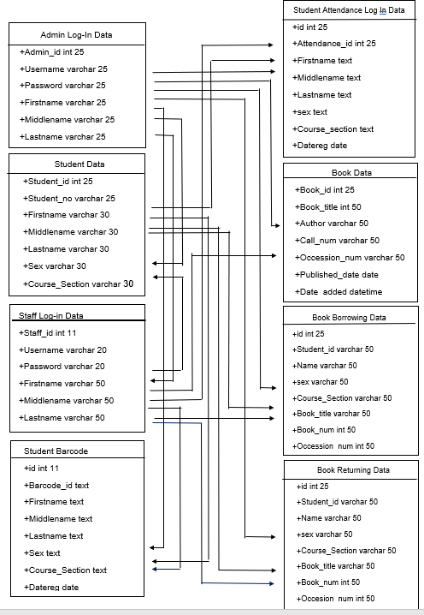The class diagram in the United Modern Language (UML) is a type of static structure diagram that describes the structures of a system by showing the system classes, their attributes, operational methods, and the relationships among objects.

### Figure 13. Class Diagram of the System

**Data Structure**

The following database tables were used to store the information inputted in the system and to collect operations that facilitate searching, sorting, and recombination of similar activities.

### 

### Table 7

### Database Structure used for Admin Data for Login

|  |  |  |  |  |
| --- | --- | --- | --- | --- |
| **FIELD** | **FIELD NAME** | **TYPE** | **SIZE** | **DESCRIPTION** |
| 1  2  3  4  5  6 | id_number  Username  Password  Firstname  Middlename  Lastname | int  varchar  varchar  varchar  varchar  varchar | 25  25  25  30  30  30 | id_number  Username  Password  First Name  Middle Name  Last Name |

### Table 8

### Database Structure Used for Student Data

|  |  |  |  |  |
| --- | --- | --- | --- | --- |
| **FIELD** | **FIELD NAME** | **TYPE** | **SIZE** | **DESCRIPTION** |
| 1  2  3  4  5  6  7 | id_number  Student_no  Firstname  Middlename  Lastname  Sex  Course_section | int  varchar  varchar  varchar  varchar  varchar  varchar | 25  25  30  30  30  30  30 | id_number  Student  First Name  Middle Name  Last Name  Sex  Course_section |

### 

### Table 9

### Database Structure Used for Staff Data for Login

|  |  |  |  |  |
| --- | --- | --- | --- | --- |
| **FIELD** | **FIELD NAME** | **TYPE** | **SIZE** | **DESCRIPTION** |
| 1  2  3  4  5  6 | id_number  Username  Password  First name  Middle name  Lastname | int  varchar  varchar  varchar  varchar  varchar | 11  20  20  50  50  50 | id_number  User Name  Password  First Name  Middle Name  Last Name |

### Table 10

### Database Structure Used for Student Barcode Attendance Data

|  |  |  |  |  |
| --- | --- | --- | --- | --- |
| **FIELD** | **FIELD NAME** | **TYPE** | **SIZE** | **DESCRIPTION** |
| 1  2  3  4  5  6  7  8 | id_number  Barcode_id  First name  Middle name  Lastname  Sex  Course_section  Datereg | int  text  text  text  text  text  text  date | 11 | id_number  Barcode id  First Name  Middle Name  Last Name  Sex  Course Section  Datereg |

### 

### Table 11

### Database Structure Used for Student Attendance Log-in Data

|  |  |  |  |  |
| --- | --- | --- | --- | --- |
| **FIELD** | **FIELD NAME** | **TYPE** | **SIZE** | **DESCRIPTION** |
| 1  2  3  4  5  6  7  8 | id_number  Attendance_id  First name  Middle name  Lastname  Sex  Course_section  Datereg | int  int  text  text  text  text  text  date | 25  25 | id_number  Attendance_id  First Name  Middle Name  Last Name  Sex  Course Section  Datereg |

### Table 12

### Database Structure Used for Books Data

|  |  |  |  |  |
| --- | --- | --- | --- | --- |
| **FIELD** | **FIELD NAME** | **TYPE** | **SIZE** | **DESCRIPTION** |
| 1  2  3  4  5  6  7 | Book_id  Book_title  Author  Call_num  Occession_num  Published_date  Date_added | int  varchar  varchar  varchar  varchar  date  DateTime | 20  50  50  50  50 | Book id  Book title  Author  Call num  Accession num  Published Date  Date_added |

### 

### Table 13

### Database Structure Used for Student Borrowing Books Data

|  |  |  |  |  |
| --- | --- | --- | --- | --- |
| **FIELD** | **FIELD NAME** | **TYPE** | **SIZE** | **DESCRIPTION** |
| 1  2  3  4  5  6  7  8 | id_number  Student_id  Name  Sex  Course_section  Book_title  Book_num  Occession_num | int  varchar  varchar  varchar  varchar  varchar  int  int | 25  25  50  50  50  50  50  50 | id_number  Student id  Name  Sex  Course section  Book title  Book num  Occession num |

### 

### Table 14

### Database Structure Used for Student Returning Books Data

|  |  |  |  |  |
| --- | --- | --- | --- | --- |
| **FIELD** | **FIELD NAME** | **TYPE** | **SIZE** | **DESCRIPTION** |
| 1  2  3  4  5  6 | id_number  Book_id  Student_no  Qty  Date  Status | int  int  int  int  date  varchar | 11  11  11  11  20 | id_number  Book id  Student no  Qty  Date  Status |

### Program Hierarchy

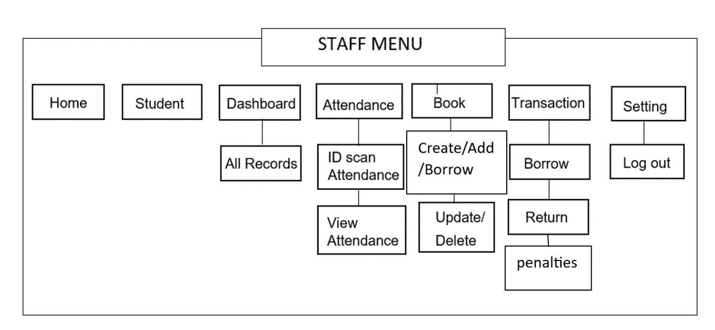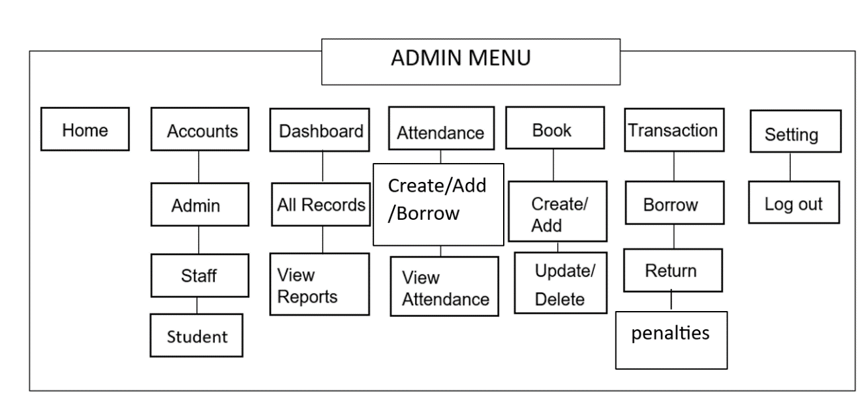A program hierarchy is a visual representation show how a system is divided into its fundamental, manageable layers. Each box in the diagram represents a module containing specific functions. The structure or design of a computer program is described using a program hierarchy. Figure 10 shows the Barcode User Counter Library System program hierarchy in BISU-Bilar.

### Figure 14. Program Hierarchy

### Functional Requirements

A functional requirement defines the function of a software system or its components. A function is a set of inputs, behavior, and outputs. It includes calculations, technical details, data manipulation, processing, and other functions the system can produce outputs. The functional requirements were obtained using the Barcode User Counter Library System in BISU-Bilar to reach the requirements. The functionalities mentioned are based on existing standard requirements of the Library System in BISU-Bilar with the approval and coordination from the management, as follows:

1. Account Management

FREQ 1: The system should enable scanning barcodes linked to student barcode IDs for swift check-in processes and updating user accounts in real time to accurately reflect borrowed and returned items.

FREQ 2: It should facilitate account creation, modification, and deletion of student data while ensuring seamless synchronization between the barcode-based user counter and the library database for accurate user tracking.

FREQ 3: The system needs to manage the account inventory by updating the student account upon borrowing or returning library items and providing accurate information about the availability of books or resources.

FREQ 4: Implement a function to calculate fines or penalties for late returns, integrating the barcode system to track due dates and automatically apply fines to user accounts, providing accurate financial records for overdue items.

1. Reports

FREQ 5: The system must generate daily reports displaying the total number of library users recorded through barcode scanning, including distinct counts for students, admin, and staff, to facilitate efficient resource allocation and understand usage patterns.

FREQ 6: It should allow for customizable reports, retrieving weekly, monthly, and yearly user statistics based on barcode scans, assisting in trend analysis, and strategic planning for library services and inventory management.

1. Attendance

FREQ 7: The system must accurately record student attendance, ensuring compatibility with the user counter library system used at BISU Bilar. This functionality should allow quick and error-free identification of individuals within the library premises.

FREQ 8: It should enable real-time updating of attendance data, promptly reflecting student entries through barcode scans. This feature ensures the immediate availability of attendance information for monitoring and administrative purposes within the BISU Bilar library.

### Non-Functional Requirements

Non-functional requirements in a system refer to characteristics that describe how the system should operate. This should be contrasted with functional requirements that define specific behaviors or functions.

1. The system must safeguard user data, encrypt user records and authentication measures, maintain confidentiality, and prevent unauthorized access to sensitive information.
2. The system interface should be intuitive and easy to navigate for admin and staff, minimizing the need for extensive training and allowing for efficient borrowing and returning actions without confusion.

### Test Case

A test case is a comprehensive procedure that thoroughly tests a feature or aspect of a feature under which a tester will determine whether or not an application or software system is operating as intended. It also consists of input values, evolution preconditions, results, and executions created for a specific objective or test condition. A variety of scenarios were tested during the acceptance testing. The test cases approach assesses the suggested system by letting users use it if they follow the guidelines. To be successful, the system must deliver the intended outcome in every test scenario. The system's user manual is contained in this test case.

**Test Case 1:**

Module: User Log-in

Severity: 1

Instructions:

1. Input username.

2. Input password.

3. Set up account.

Expected Result:

* User can access the system depending on their role.

**Test Case 2:**

Module: Adding Admin User

Severity: 1

Instructions:

1. On the home page, click the Account button and select Admin.

2. Input the user’s information.

3. Click the "Add Admin" button to save the account.

Expected Result:

* The account should be successfully saved.
* The newly added account is displayed and can be used for another login session.

**Test Case 3:**

Module: Adding Staff User

Severity: 1

Instructions:

1. On the home page, click the Account button and select Staff.

2. Input the user’s information.

3. Click the "Add Staff" button to save the account.

Expected Result:

* The account should be successfully saved.

The newly added account is displayed and can be used for another login session.

**Test Case 4:**

Module: Adding Faculty/Visitor Account

Severity: 1

Instructions:

1. On the home page, click the Account button and select Faculty/Visitor.

2. Input the faculty/visitor information.

3. Save the data by clicking the "Add Faculty/Visitor" button.

Expected Result:

* The data should be successfully saved.

The newly added data is displayed, and the ID number can be used for attendance scanning.

**Test Case 5**

Module: Adding Student Account

Severity: 1

Instructions:

1. On the home page, click the Account button and select Student.

2. 3Input the student information.

3. Click the "Add Student" button to save the student data.

Expected Result:

* The data should be successfully saved.

The newly added data is displayed, and the ID number can be used for attendance scanning.

**Test Case 6:**

Module: Viewing All Data Reports

Severity: 1

Instructions:

1. On the home page, click the Dashboard button.

2. Select the "View Reports" button to display selected reports.

Expected Result:

* It should display all the total reports.
* The selected reports should display the total recorded data.

**Test Case 7:**

Module: Scan ID for Attendance

Severity: 1

Instructions:

1. On the home page, click the Attendance button.

2. Scan the ID barcode on the scanner for attendance.

Expected Result:

* It should display the student data after successfully scanning the ID.

**Test Case 8:**

Module: Adding Books Data

Severity: 1

Instructions:

1. On the home page, click the Book button.

2. Input the book's information.

3. Click the "Add Book" button to save the book data.

Expected Result:

* The book should be successfully saved.
* The newly added book is displayed and can be borrowed.

**Test Case 9:**

Module: Borrowing Book

Severity: 1

Instructions:

1. On the home page, click the Transaction button and select "Borrow Books."

2. Input the borrower's and book's data.

3. Save the borrowed data by clicking the "Borrow Book" button.

Expected Result:

* The book should be successfully borrowed.
* The newly borrowed data is displayed in the "Return Books" menu.

**Test Case 10:**

Module: Returning Borrowed Book

Severity: 1

Instructions:

1. On the home page, click the Transaction button and select "Return Books."

2. Select the borrowed data to display.

3. Click the "Return" button to return the book's data.

Expected Result:

* The book should be successfully returned.
* The newly returned book can be deleted and removed from the displayed table.

**Test Case 11:**

Module: Deleting Penalty Data

Severity: 1

Instructions:

1. On the home page, click the Transaction button and select "Penalties."

2. Select the penalty data to display.

3. Click the "Delete" button to remove the penalty data.

4. Select the ban time duration for the penalty data.

Expected Result:

* The penalty data should be successfully deleted.
* Penalty data older than the selected ban time duration can now be removed.

**Test Case 12:**

Module: Log Out Account

Severity: 1

Instructions:

1. On the home page, click the Settings button and select "Logout."

2. In the confirmation message, select "Yes."

Expected Result:

* It should display a confirmation message first.

After clicking "Yes," the account should be successfully logged out.

### Technical Requirements

People select hardware and software components and identify people involved in the operation. This is necessary for proper usage so the system can be used to its total capacity. The hardware component refers to the physical part of the computer. This includes the (CPU). This consists of the tower casing, microprocessor, hard disk, RAM, UPS, monitor, mouse, and keyboard. However, there are only three (3) components that facilitate the processing of data. The microprocessor, hard disk drive (HDD), and Random Access Memory (RAM) are components. Thus, these components were just specified in the presentation.

Software refers to programs the computer machine can read and perform with the desired instruction. It is a set of instructions that the computer translates into a machine-readable format to be manipulated. In addition, the software produces an output that can be understood in a human-readable format. Peopleware is the user that operates the programs installed on the computer. The user should be capable of operating the system to process information effectively.

### Minimum Hardware Specification

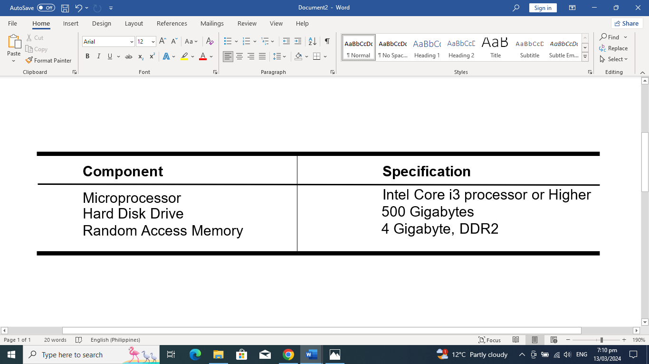This covers the minimum hardware specification the system needs to function correctly as intended and expected. The considerations of these specifications were based on what is available in the market and what most computer package system offers.

Table 15. Minimum Android Hardware Specifications

### Minimum Software Specification

The Library Management System with Barcode User Counter in BISU-Bilar requires various software to function correctly. This software was enumerated below with its corresponding specifications. The specifications provided were based on the computer unit's specifications utilized during the 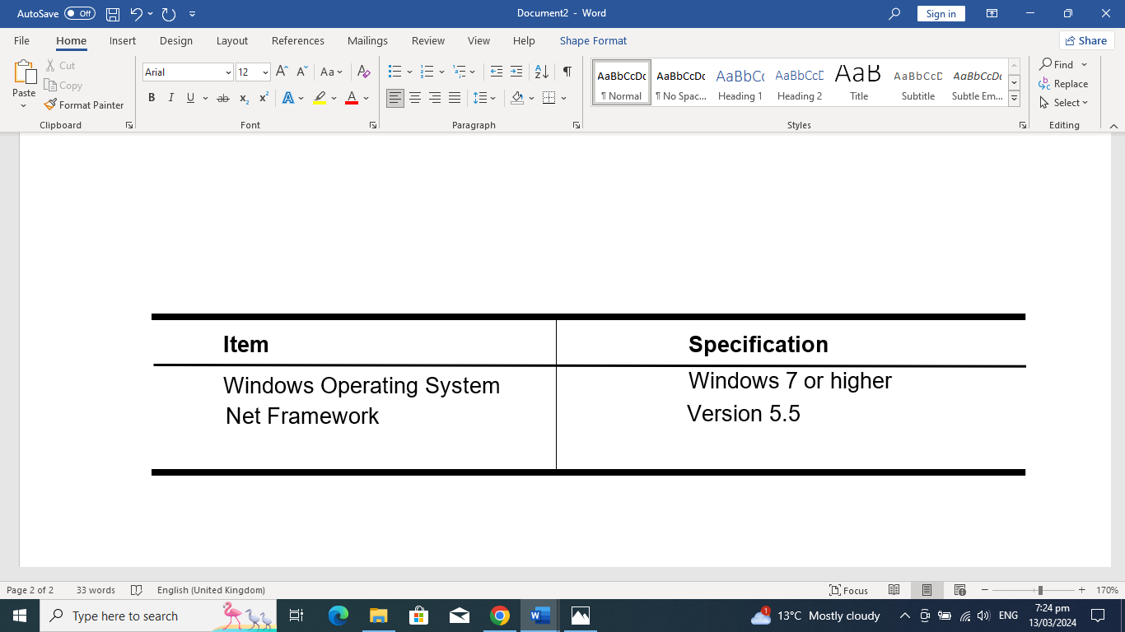system's development.

### Table 16. Minimum Android Software Specifications

### Screen Layout

The screen layout is one of the many attributes of the system's user-friendliness. It should be designed so that browsers can navigate the system quickly and easily and clearly recognize the tasks the users need to perform.

The Preview below shows the sign-in display form for a particular user.

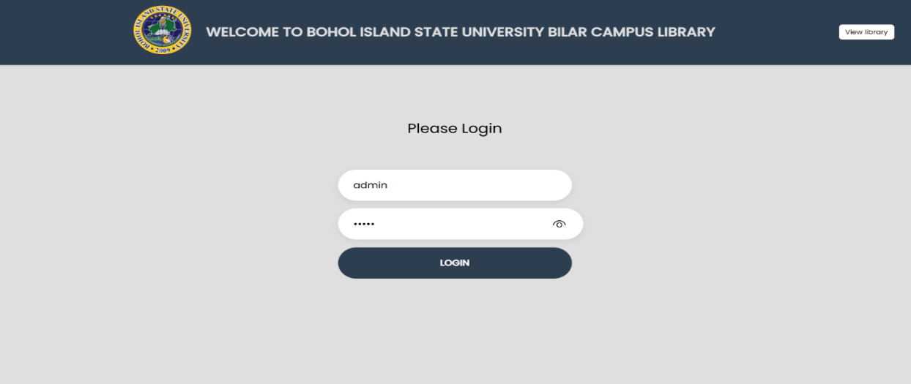

### 

### Preview 1. Admin Log in

The preview below shows the system's home page.

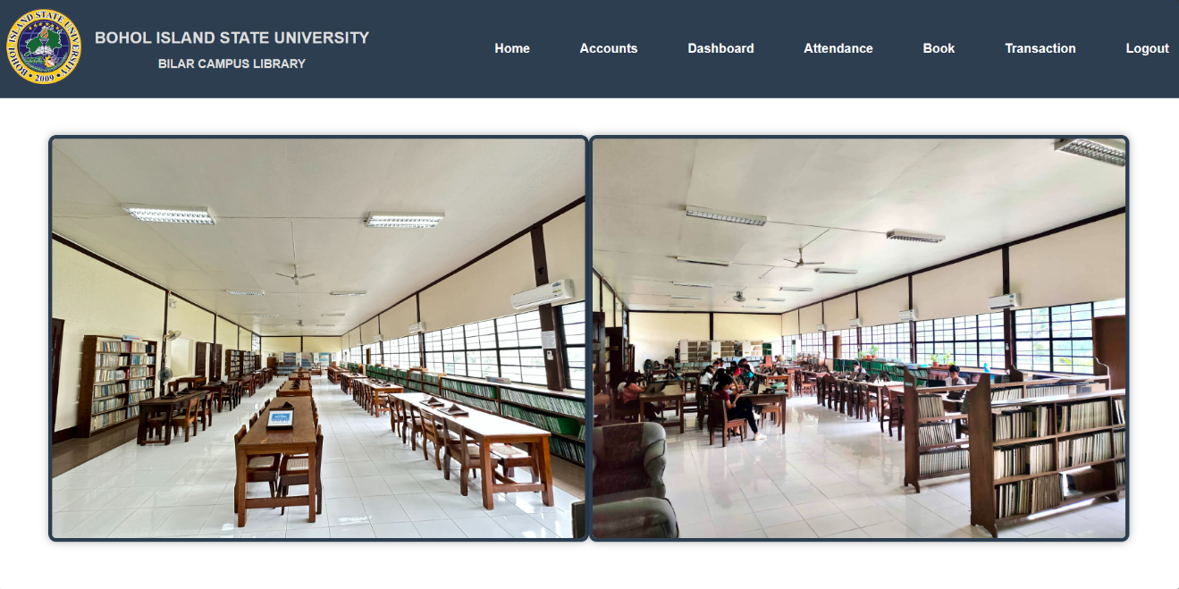

### Preview 2. Home Page

The preview below shows the addition of a new admin member of the system.

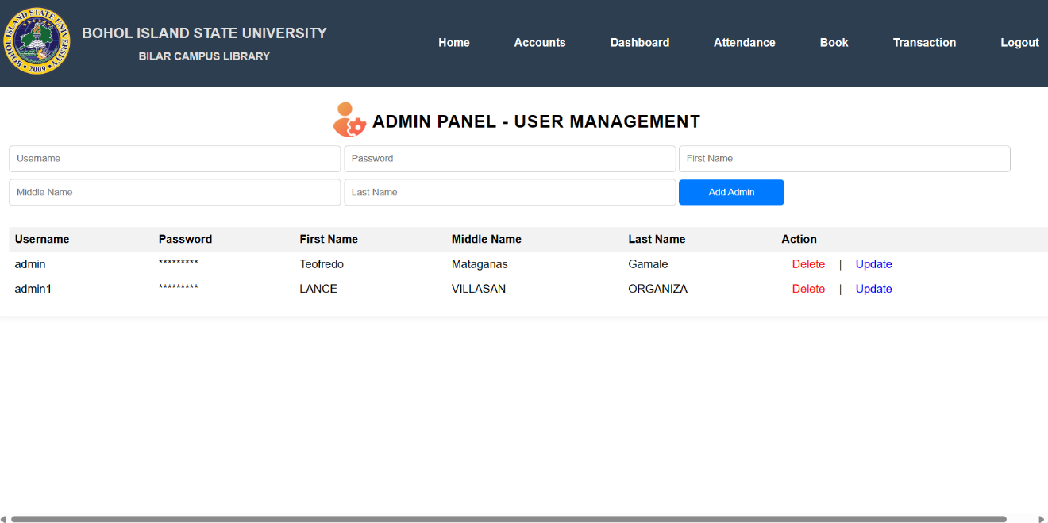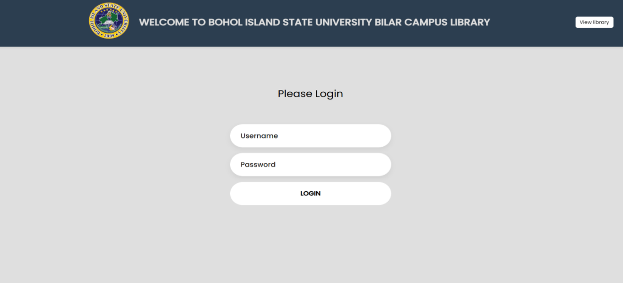

### Preview 3. User for Admin Management

The preview below shows the addition of a new staff member to the system.

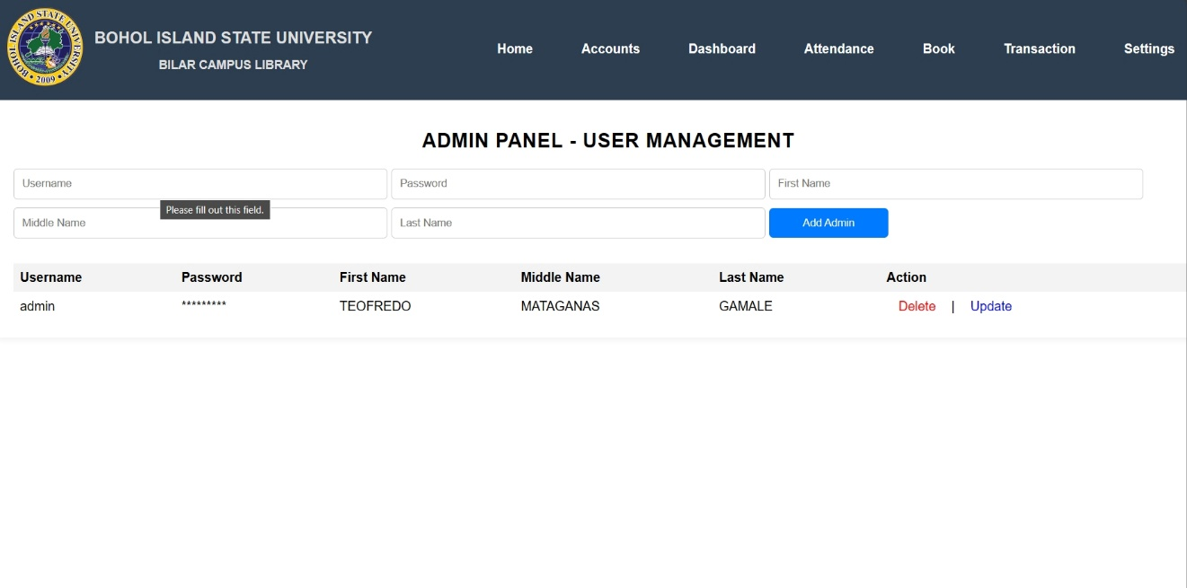

### Preview 4. User for Staff

The preview below shows the addition of a new faculty/visitor member to the system.

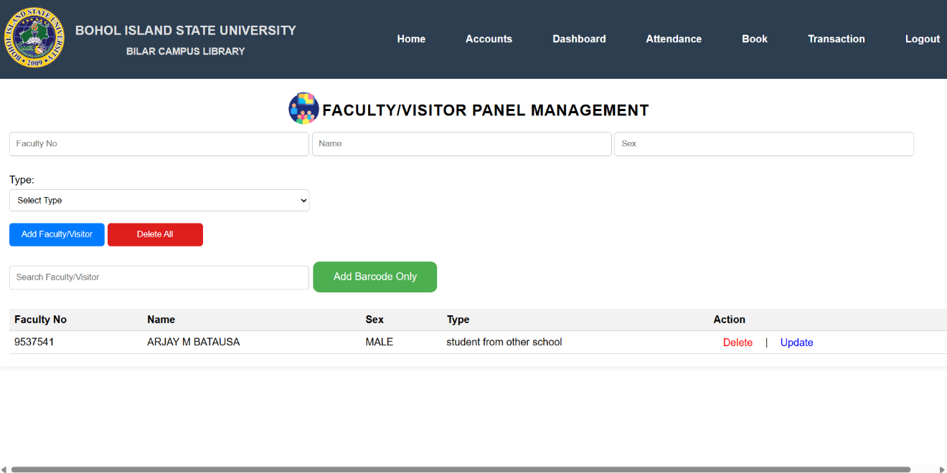

### Preview 5. For Faculty/Visitor Management

The preview below shows the addition of a new student member to the system.

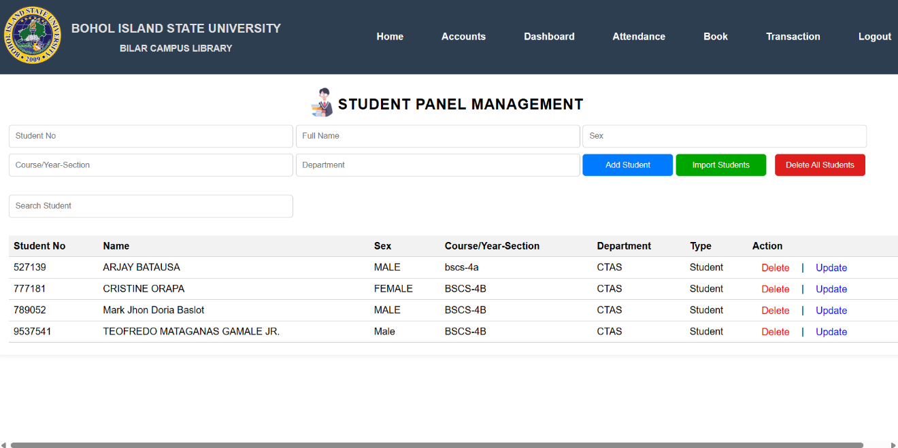

### Preview 6. Dashboard

The preview below shows the overall system reports.

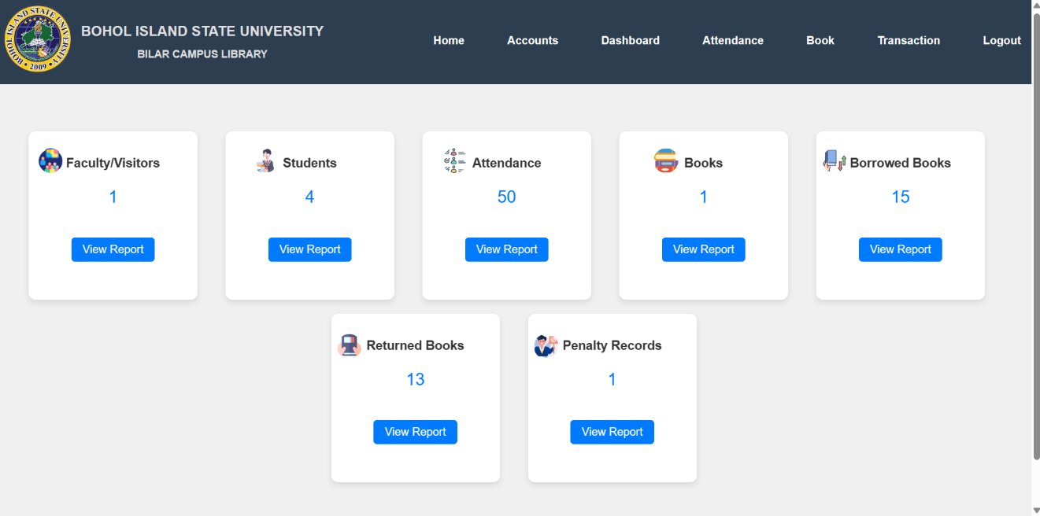

### Preview 7.Reports

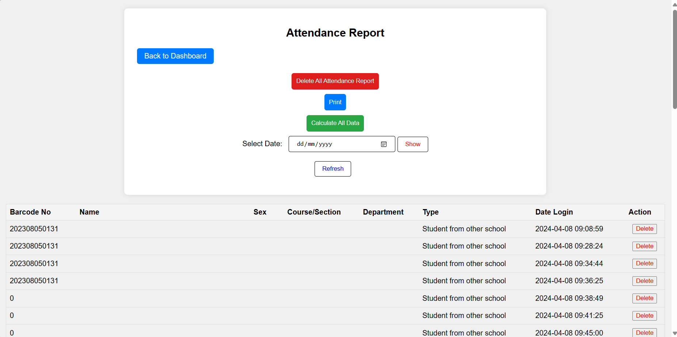The preview below shows the students' attendance report.

### 

### Preview 8. Student Attendance

The preview below shows the transactions for borrowing books.

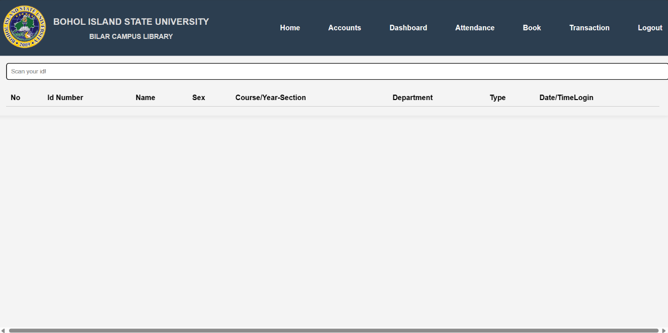 Preview 9. Books Transaction

The preview below shows the reports of attendance per month

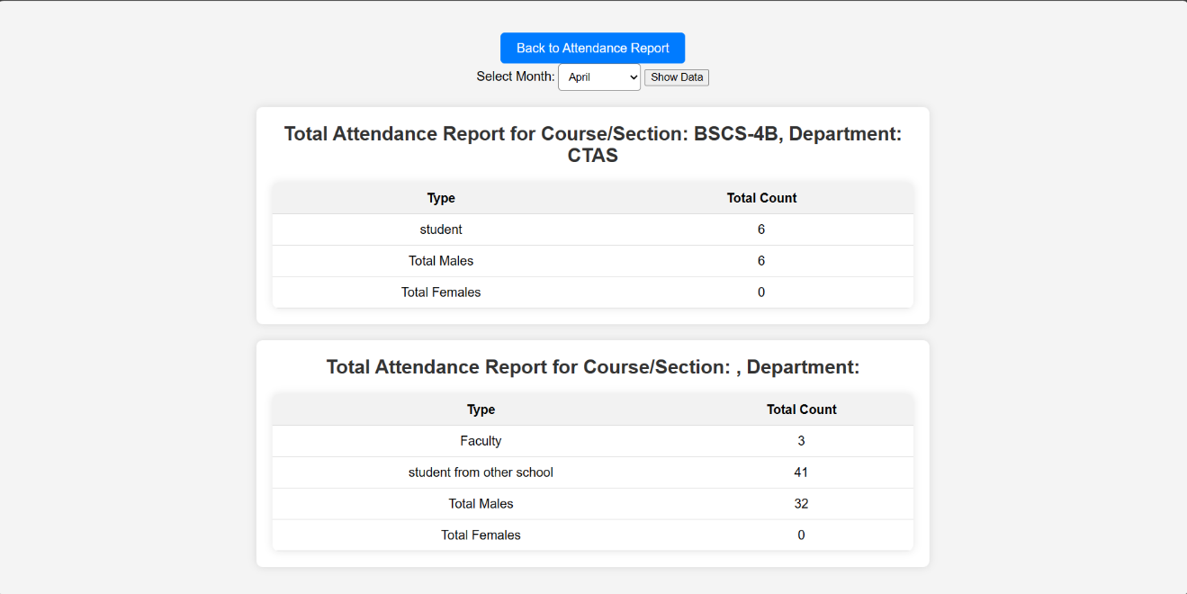 Preview 10. Report for Attendance per month

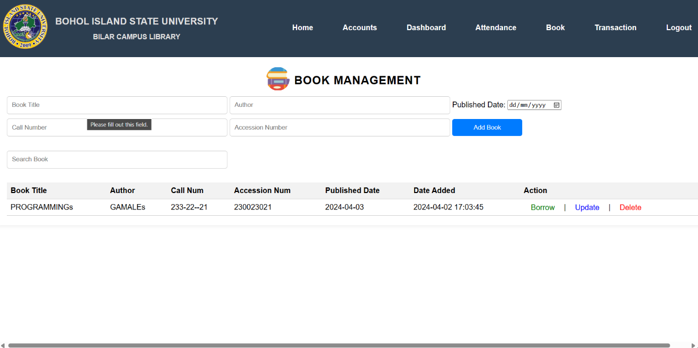The preview below shows the system's book management.

### Preview 11. Book Management

The preview below shows the system's book borrowing transaction.

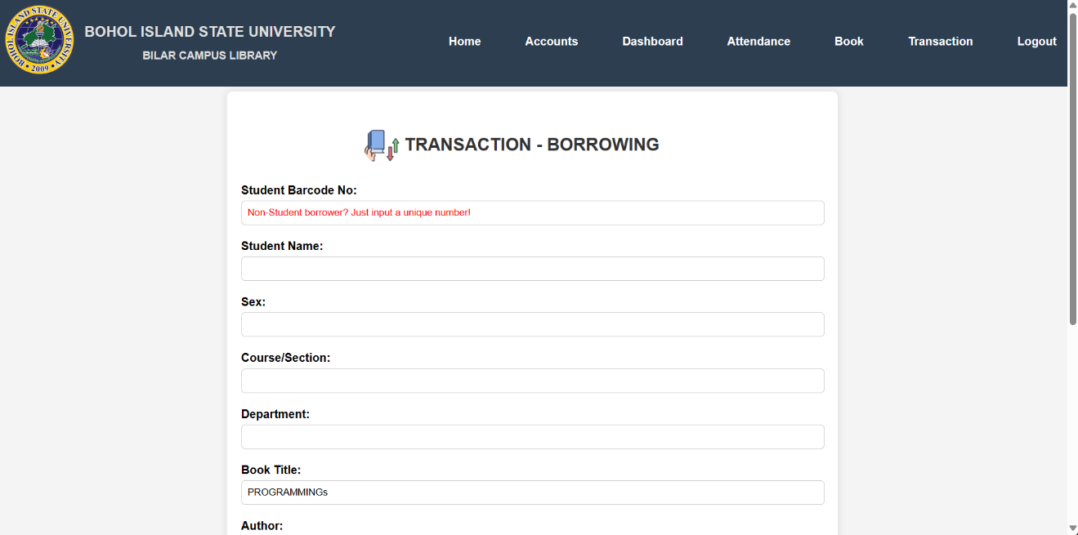

### 

### Preview 12. BookTransaction

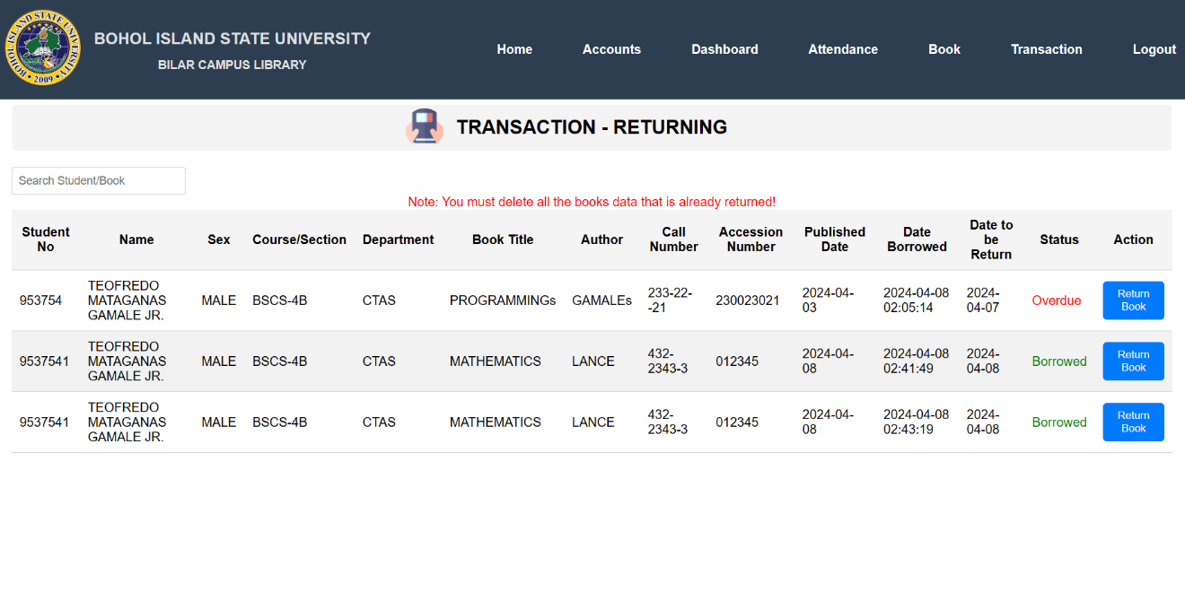The preview below shows the system's book-returning transaction.

### Preview 13. Book Transaction

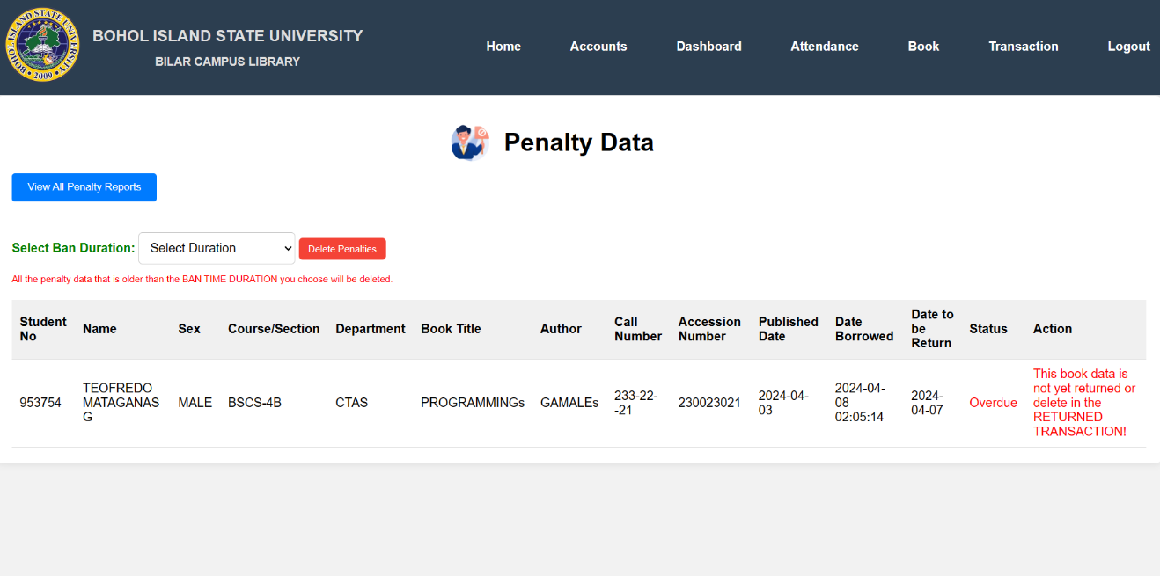The preview below shows the system's book penalty data records.

### Preview 14. Penalty Data

### Economic Economic Performance Evaluation

Table 17 shows the initial investment and manual operating cost of the Library Management System with a Barcode User Counter in BISU-Bilar. Performance was assessed in terms of initial investment. The initial investment was the client's required amount before the system’s operation and deployment started.

### Table 17: Economic Initial Investment

|  |  |  |  |  |
| --- | --- | --- | --- | --- |
| **Item** | **Qty** | **Unit** | **Unit Price** | **Total** |
| A. Initial Investment | | | | |
| 1. Hardware | | | | |
| Computer Package | 1 | Set | ₱ 15,000.00 | (Existing) |
| Laptop | 1 | Piece | ₱29,000.00 | (Existing) |
| Barcode Scanner | 1 | Piece | ₱ 850.00 | ₱ 850.00 |
| **Total Initial Investment** | | | | ₱ 850.00 |

### Testing and Evaluation

Testing evaluation refers to assessing software testing activities' effectiveness, accuracy, and comprehension. Testing evaluation helps determine if the software meets the specified requirements and performs as expected. It involves analyzing test results, identifying defects, tracking defects to resolution, and generating reports to provide insights into the overall quality of the software.

### 

### System Usability

Table 18 show below that based on the results of the system usability test using the questionnaire prepared by ISO 25010, the target users perceived the system to be acceptable, with a general rating of "Agree." The respondents stated that the system was suitable for recording student data and met their expectations in terms of functions and capabilities. There may be room for improvement, but the system performed well in the test overall.

|  |  |  |  |
| --- | --- | --- | --- |
| **Criteria for System Usability** | **Weighted**  **Mean** | | **Rating**  **Strongly Agree** |
| Functional completeness | | 4.8 | Strong Agree |
| Functional correctness | | 4.53 | Agree |
| Functional appropriateness | | 4.73 | Strong Agree |
| Time behavior | | 4.53 | Agree |
| Resource utilization | | 4.6 | Strong Agree |
| Resource utilization | | 4.46 | Agree |
| Co-existence | | 4.53 | Agree |
| Interoperability | | 4.4 | Agree |
| Appropriateness Recognizability | | 4.66 | Agree |
| Learnability | | 4.53 | Agree |
| Operability | | 4.53 | Agree |
| User error protection | | 4.6 | Strong Agree |
| User interface aesthetics | | 4.26 | Agree |
| Accessibility | | 4.8 | Agree |
| Maturity | | 4.53 | Agree |
| Availability | | 4.46 | Agree |
| Recoverability | | 4.4 | Agree |
| Confidentiality | | 4.8 | Strong Agree |
| Integrity | | 4.53 | Agree |
| Accountability | | 4.33 | Agree |
| Authenticity | | 4.6 | Strong Agree |
| Non-repudiation | | 4.6 | Strong Agree |
| Modularity | | 4.46 | Agree |
| Reusability | | 4.33 | Agree |
| Analyzability | | 4.46 | Agree |
| Modifiability | | 4.6 | Strong Agree |
| Testability | | 4.46 | Agree |
| Adaptability | | 4.4 | Agree |
| Installability | | 4.53 | Agree |
| Replaceability | | 4.4 | Agree |
| **Overall Mean** | | 4.52 | **Agree** |

Table 18. System Usability Assessment Result N=10

**Chapter 3**

**SUMMARY OF FINDINGS, CONCLUSION, AND RECOMMENDATION**

### Summary of Findings

Based on the survey results, the developers found out that the institution uses semi-manual processes to manage library-related information. Moreover, the institution needs a system for record management, particularly for keeping and storage, which leads to misplacement and Attendance Monitoring record duplication, more extended time in retrieving information and updates, and time-consuming generation of Inventory information. The identified problems and issues in managing records led the developers to develop a solution that secures the library and data information to prevent loss or misplacement, ease of access, and timely generation of inventory and attendance manually.

Based on the identified needs, a Library Management System with a Barcode User Counter in BISU-Bilar is familiar with the following modules: Accounts, Dashboard, Student Barcode ID, Incrementing Counter, Data Logging, and Transactions like borrowing and borrowing. The developed system was a pilot system and was evaluated in terms of system usability. Based on the evaluation result, the respondents or the users tended to agree on rating the system, Indicating the achievements of individual expectations, particularly on the features such as ease of use, visual clarity, language, and application, as general.

The developed system was evaluated in terms of system usability. Based on the result of the evaluation, which has an average rating of 4.52, the respondents of the users tend to agree that the system indicates achievement of individual expectations, particularly on features such as ease of use and visual clarity: language and its application in general.

### Conclusion

Based on the study's findings, the researchers have concluded that the institutions concerned need a system, and students need help in current attendance monitoring and library management. The library management system with a barcode user counter in BISU-Bilar has improved record management efficiency and attendance by scanning barcodes that fit the client's requirements and expectations. Adopting the system requires minimal investment and operational cost, hence being affordable and economical.

### Recommendations

Based on the conclusions drawn from the study it is recommended that the developed system be implemented at the Library Management System with Barcode User Counter in BISU-Bilar, where the study is being done. The researchers developed the following recommendations to resolve the needs identified during the study.

1. Future researchers can improve the efficiency and accuracy of library operations, making it easier for students and staff to manage library resources effectively.

2. Researchers should consider incorporating data analytics capabilities into the system to analyze user behavior, optimize resource allocation, and continuously improve library services based on insights gained from usage patterns.

3. Researchers could explore integrating the Library Management System with the institution's existing student information or learning management system. Books System provides library automation solutions lke atriuum, which supports barcode scanning and oofers feautures for managing library collections and users accounts.

4. Training or Seminar must be conducted to the primary or targetoriented and operation of the new system. Offer virtual training sessions and online support resources for library staff to familiziesnthem with the new online system, including barcode user counter, circulation process, and data management.

5. Convert the library catalog from physical records to a digital format that can beaccessed online. Ensure the digital catalog is searchable, users-friendly, and includes barcode information for efficient tracking.

6. Develop a mobile app that integrates with the online library management system, allowaing users to search for books, check, availability, scan barcodes for checkouts and receive notifications. Ensure barcode scanning functionality is seamless in the app.

### REFERENCES

Chanda, A. (2019). "Barcode Technology and its Application in Libraries." Library Philosophy and Practice(e-journal).

Chanwoo Chun, Jung-Young Son. (2012). "Pilot-based 2D-barcode image restoration using successive interference cancellation." In IEEE International Conference on Consumer Electronics (ICCE).

Corey, A. et al. (2008). "Automatic Identification and Data Capture (AIDC): The Foundation of Military Logistics." Transportation Security. Elsevier.

Jeevan. (2000). "The Application of Barcode in IT."

K. Lakshmi Sudha et al. (2015). "Barcode Based Student Attendance System."

Lim, EP. Chen, H. Neuhold, E. et al. “International Journal on Digital Library”, Springer-Verlag (Nov 2004)

Seideman, T. (2007). "Barcodes Sweep the World: Wonder of Modern Technology."

Saraswat, C., & Kumar, A. (2010). "An Efficient Automatic Attendance System Using Fingerprint Verification Technique." International Journal on Computer Science & Engineering.

Salah Elaskari et al. (202*). "Using Barcode to Track Student Attendance and Assets in Higher Education Institutions."

VishwakarmaDharmesh[https://www.slideshare.net/DharmeshVishwakarma/stude nt-](https://www.slideshare.net/DharmeshVishwakarma/stude%09nt-) attendance- management-system-using-barcode Ret

**APPENDICES**

**APPENDICES A**

**LETTER OF INTENT**

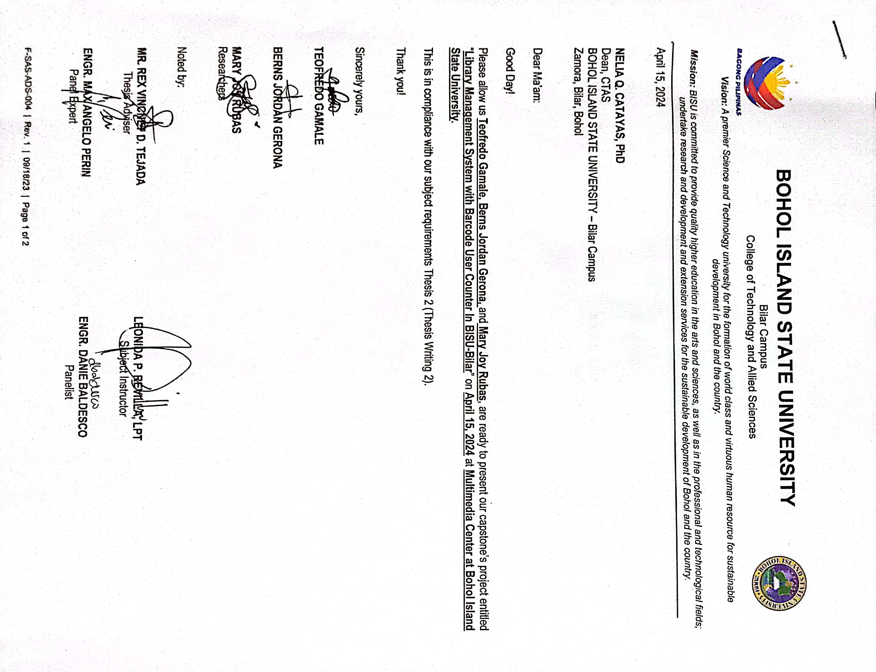

**APPENDICES B**

**GUIDE QUESTIONS FOR INTERVIEW**

1. Why is it important to have a user counter, in a library system that uses barcodes? What purpose does it serve?
2. What are the benefits and possible downsides of incorporating a user counter, into the library system, at BISU-Bilar or any other library?
3. How does the integration of a user counter improve the overall efficiency and management of library resources?
4. What are the main characteristics and capabilities of the user counter system, in BISU-Bilar that is based on barcodes?
5. What measures does the system implement to address concerns regarding user privacy and data security?
6. How does the system address concerns relate to user privacy and the security of data?
7. What are some of the difficulties and hurdles that may arise when implementing a system, like this and what steps can be taken to overcome them?
8. How does the system play a role, in gathering and analyzing data, for managing libraries and making decisions?
9. What feedback or experiences have users shared about using this system in Bisu Bilar or other similar institutions?
10. Are there any plans or improvements being considered for the user counter system, in BISU-Bilar that relies on barcodes?

**APPENDICES C**

**LETTER PF IMPLEMENTATION**

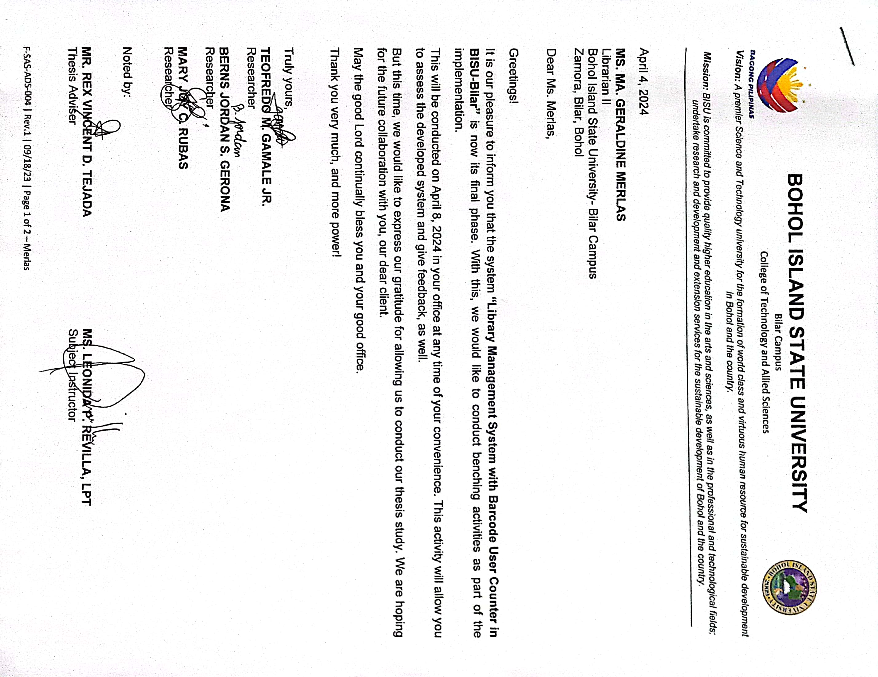

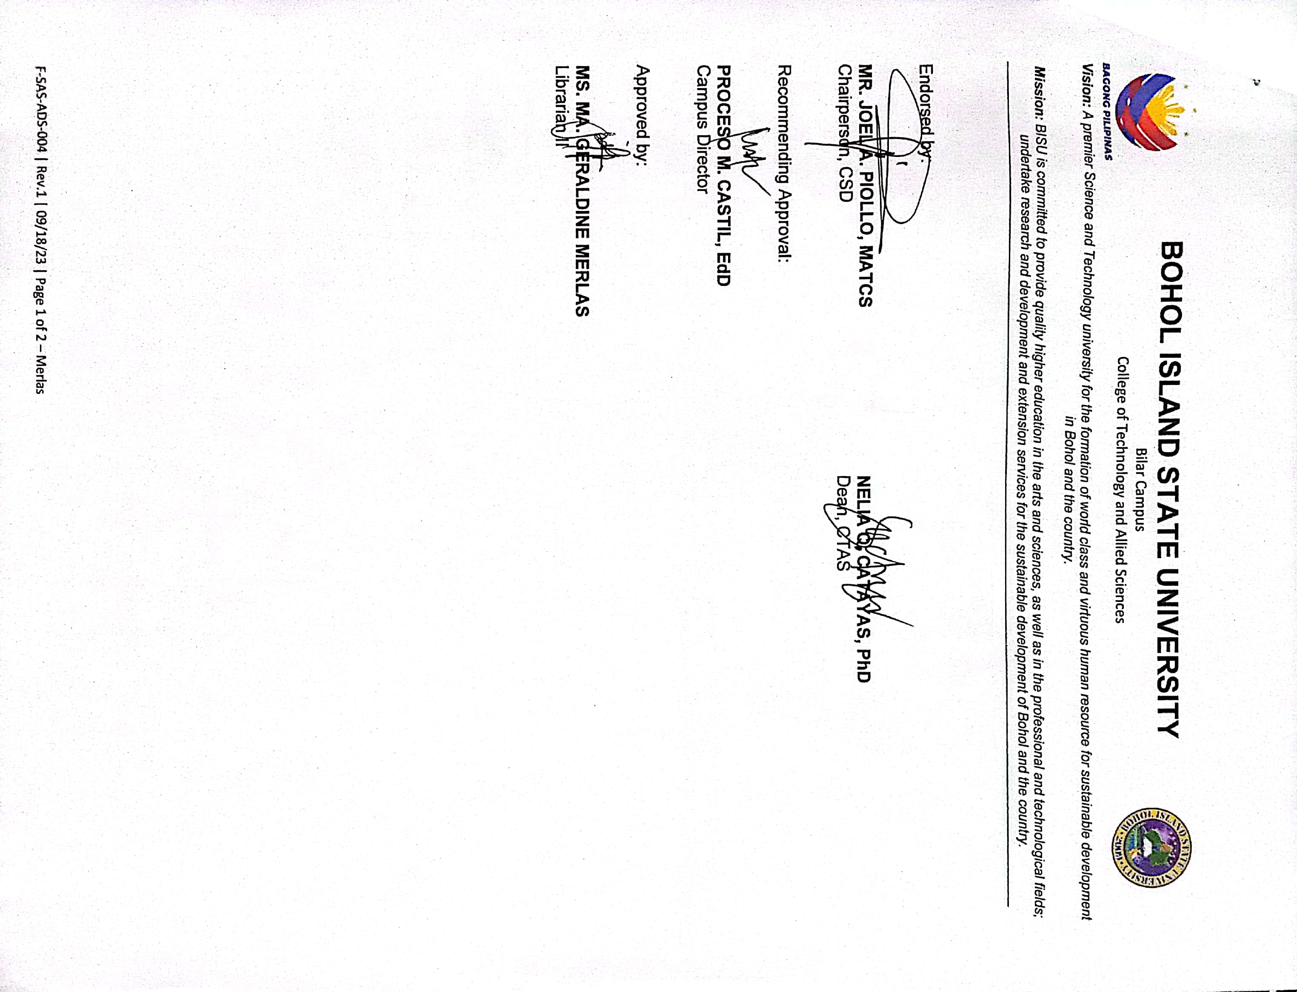

**APPENDICES D**

**APPENDICES D**

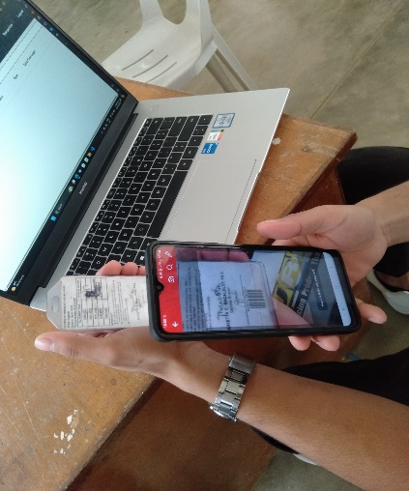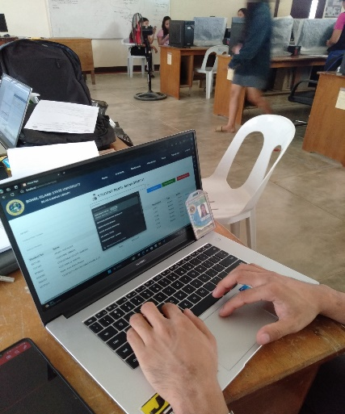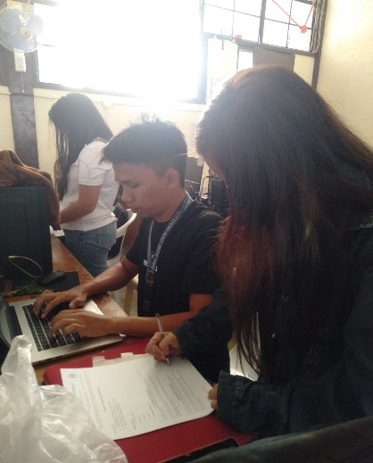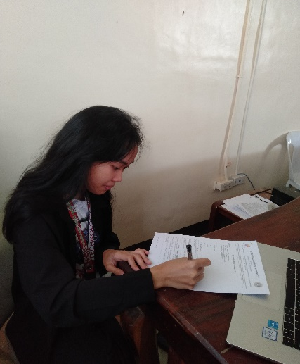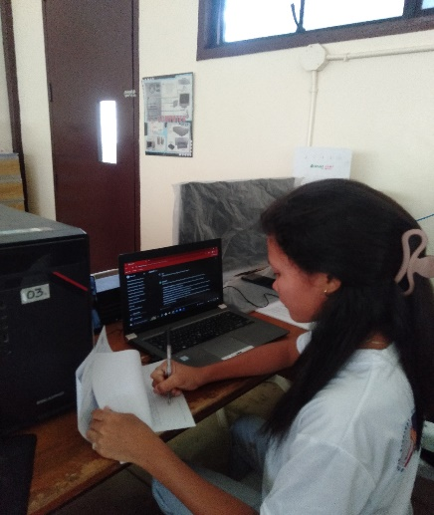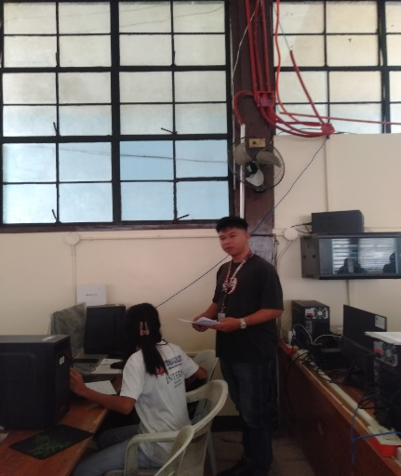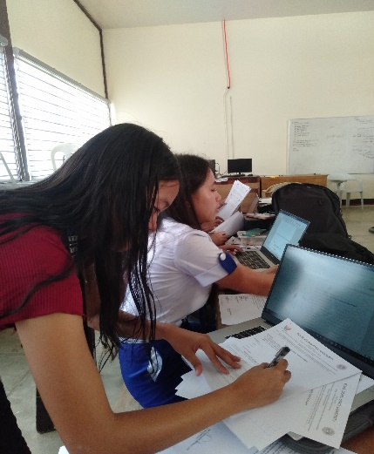

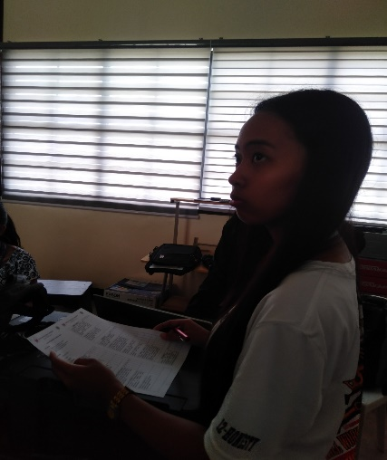

**APPENDICES E**

**System Usability Questionnaire**

**Instructions:**

* Please rate the usability of the system
* Try to respond to all the items
* For items that are not applicable, use N/A
* Make sure these fields are filled in

**Rating Scale:**

5- Strongly Agree

4- Agree

3- Neutral

2- Disagree

1. Strongly Disagree

|  |  |  |  |  |  |
| --- | --- | --- | --- | --- | --- |
| **FUNCTIONALITY SUITABILITY** | **5** | **4** | **3** | **2** | **1** |
| Functional completeness. The set of functions covers all the specified tasks and user objectives. |  |  |  |  |  |
| Functional correctness. The project provides the correct results with the needed degree of precision. |  |  |  |  |  |
| Functional appropriateness. The functions facilitate the accomplishment of specified tasks and objectives. |  |  |  |  |  |
| **PERFORMANCE EFFICIENCY** | **5** | **4** | **3** | **2** | **1** |
| Time behavior. The response and processing times and throughout rates of a product or system, when performing its functions, meet requirements. |  |  |  |  |  |
| Resource utilization. The amounts and types of resources used by a product or system, when performing its functions, meet requirements. |  |  |  |  |  |
| Resource utilization. The maximum limits of a product or system parameter meet requirements. |  |  |  |  |  |

|  |  |  |  |  |  |  |  |  |  |
| --- | --- | --- | --- | --- | --- | --- | --- | --- | --- |
| **COMPATIBILITY** | **5** | **4** | | **3** | | **2** | | **1** | |
| Co-existence. A product can perform its required functions efficiently while sharing a common environment and resources with other products, without detrimental impact on any other product. |  |  | |  | |  | |  | |
| Interoperability. Two or more systems, products or components can exchange information and use the information that has been exchanged. |  |  | |  | |  | |  | |
| **USABILITY** | **5** | **4** | | **3** | | **2** | | **1** | |
| Appropriateness Recognizability. Users can recognize whether a product or system is appropriate for their needs. |  |  | |  | |  | |  | |
| Learnability. The project can be used by specified users to achieve specified goals of learning to use the product or system with effectiveness, efficiency, freedom from risk and satisfaction in a specified context of use. |  |  | |  | |  | |  | |
| Operability. The project has attributes that make it easy to operate and control. |  |  | |  | |  | |  | |
| User error protection. The project protects user against making errors. |  |  | |  | |  | |  | |
| User interface aesthetics. User interface enables pleasing and satisfying interaction for the user. |  |  | |  | |  | |  | |
| Accessibility. The project can be used by people with the widest range of characteristics and capabilities to achieve a specified goal in a specified context of use. |  |  | |  | |  | |  | |
| **RELIABILITY** | **5** | **4** | | **3** | | **2** | | **1** | |
| Maturity. The project or component meets needs for reliability under normal operation. |  |  | |  | |  | |  | |
| Availability. The project or component is operational and accessible when required for use. |  |  | |  | |  | |  | |
| Recoverability. In the event of an interruption or a failure, the project can recover the data directly affected and re-establish the desired state of the system. |  |  | |  | |  | |  | |
| **SECURITY** | **5** | | **4** | | **3** | | **2** | | **1** |
| Confidentiality. The project ensures that data are accessible only to those authorized to have access. |  | |  | |  | |  | |  |
| Integrity. The project or component prevents unauthorized access to, or modification of, computer programs or data. |  | |  | |  | |  | |  |
| Accountability. The actions of an entity can be traced uniquely to the entity. |  | |  | |  | |  | |  |
| Authenticity. The identity of a subject or resource can be provided to be the one claimed. |  | |  | |  | |  | |  |
| Non-repudiation. Actions or events can be proven to have taken place, so that the events or actions cannot be repudiated later. |  | |  | |  | |  | |  |
| **MAINTAINABILITY** | **5** | | **4** | | **3** | | **2** | | **1** |
| Modularity. The project is composed of discrete components such that a change to one component has minimal impact on other components. |  | |  | |  | |  | |  |
| Reusability. An asset can be used in more than one system, or in building other assets. |  | |  | |  | |  | |  |
| Analyzability. The effectiveness and efficiency with which it is possible to assess the impact on the project of an intended change to one or more of its parts, or to diagnose a project for deficiencies or causes of failures, or to identify parts to be modified. |  | |  | |  | |  | |  |
| Modifiability. The project can be effectively and efficiently modified without introducing defects or degrading existing product quality. |  | |  | |  | |  | |  |
| Testability. The effectiveness and efficiency with which test criteria can be established for the project and test can be performed to determine whether those criteria have been met. |  | |  | |  | |  | |  |
| **PORTABILITY** | **5** | | **4** | | **3** | | **2** | | **1** |
| Adaptability. The degree to which a product or system can effectively and efficiently be adapted for different or evolving hardware, software, or other operational or usage environments. |  | |  | |  | |  | |  |
| Installability. The effectiveness and efficiency with which a product or system can be successfully installed and/or uninstalled in a specified environment. |  | |  | |  | |  | |  |
| Replaceability. A product can replace another specified software product for the same purpose in the same environment. diagnose a project for deficiencies or causes of failures, or to identify parts to be modified. |  | |  | |  | |  | |  |

**APPENDICES F**

**User’s Manual’s**

**A. User Account Login**

**User Login**

Steps:

1. On the login page of the system input your registered username and password.
2. Click the “Login” Button
3. System will automatically identify your role (Admin/Staff) then load the system for the access role.

Expected Results:

1. Users can access the system depending on the user role.

Clean Up:

1. Click the Settings then click the “Logout” Button below.

**B. Account Registration**

**Admin Registration**

Steps:

1. On the accounts button click the “Admin” text below.
2. Input needed field data.
3. Click “Add Admin” button.

Expected Results:

1. New Admin user was registered on the system.

Clean Up:

1. Click the home button to close the page.

**Staff Registration**

Steps:

1. On the accounts button click the “Staff” text below.
2. Input needed field data.
3. Click “Add Staff” button.

Expected Results:

1. New Staff user was registered on the system.

Clean Up:

1. Click the home button to close the page.

**Faculty/Visitor Registration**

Steps:

1. On the accounts button click the “Faculty/Visitor” text below.
2. Input needed field data.
3. Click “Add Faculty/Visitor” button.

Expected Results:

1. New Faculty/Visitor user was registered on the system.

Clean Up:

1. Click the home button to close the page.

**Student Registration**

Steps:

1. On the accounts button click the “Student” text below.

2. Input needed field data.

3. Click “Add Student” button.

Expected Results:

1. New Student user was registered on the system.

Clean Up:

1. Click the home button to close the page.

**D. View Data Reports**

**View Reports**

Steps:

1. On the home page, click the “Dashboard” button.
2. Select the “View Reports” button to display selected reports.

Expected Results:

1. It displays all the total reports.
2. The selected reports display the total recorded data.

Clean Up:

1. Click the home button to close the page.

**E. Scan ID for Attendance**

**Scan ID**

Steps:

1. On the home page, click the attendance button.
2. Scan the ID barcode on the scanner for attendance

Expected Results:

1. It displays the student data after successfully scanning the ID.

Clean Up:

1. Click the home button to close the page

**F. Transaction**

**Adding Book Data**

Steps:

1. On the home page, click the Book button.
2. Input the book’s information.
3. Click the “Add Book” button to save the book data.

Expected Results:

1. New book data is successfully saved.
2. The newly added book is displayed and can be borrowed.

Clean Up:

1. Click the home button to close the page.

**Borrowing Book**

Steps:

1. On the home page, click the Transaction button and select “Borrow Books” button.
2. Input the borrower’s and book’s data.
3. Click the “Borrow book” button to save the borrowed data.

Expected Results:

1. The book is successfully borrowed.
2. The newly borrowed book data is displayed in the “Returned Books” menu.

Clean Up:

1. Click the home button to close the page.

**Returning Book**

Steps:

1. On the home page, click the Transaction button and select “Return Books” button.
2. Select the borrowed data displayed.
3. Click the “Return” button to return the book’s data.

Expected Results:

1. The book would be successfully returned.
2. The newly returned book can now be deleted and removed from the displayed table.

Clean Up:

1. Click the home button to close the page.

**Deleting Penalty Data**

Steps:

1. On the home page, click the Transaction button and select “Penalties” button.
2. Select the penalty data to displayed.
3. Click the “Delete” button to remove the penalty data.
4. Select the ban time duration for the penalty data.

Expected Results:

1. The penalty data would be successfully deleted.

**G. User Accounts Logout**

**Logout Account**

Steps:

1. On the home page, click the Settings button and select “Logout” button.
2. In the confirmation message, select “Yes” button.

Expected Results:

1. It displayed a confirmation message first. After clicking “Yes” button the account would be successfully logged out.

Clean Up:

1. Click the cancel button to close the page.

**APPENDICES G**

**SOURCE CODE**

<!DOCTYPE html>

<html lang="en">

<head>

<?php include 'top_bar.php'; ?>

<meta charset="UTF-8">

<meta name="viewport" content="width=device-width, initial-scale=1.0">

<title>Admin Panel</title>

<link rel="stylesheet" href="css/admin.css">

</head>

<body>

<div class="container">

<h2>Admin Panel - User Management</h2>

<form method="post">

<input type="text" name="username" placeholder="Username" required>

<input type="password" name="password" placeholder="Password" required>

<input type="text" name="firstname" placeholder="First Name" required>

<input type="text" name="middlename" placeholder="Middle Name">

<input type="text" name="lastname" placeholder="Last Name" required>

<input type="submit" name="addAdmin" value="Add Admin">

</form>

<?php

include "connect.php";

function displayUsers($conn) {

$sql = "SELECT * FROM admin";

$result = $conn->query($sql);

if ($result->num_rows > 0) {

echo "<table>

<tr>

<th>Username</th>

<th>Password</th>

<th>First Name</th>

<th>Middle Name</th>

<th>Last Name</th>

<th>Action</th>

</tr>";

while($row = $result->fetch_assoc()) {

$hashedPassword = "*********";

echo "<tr>

<td>".$row["username"]."</td>

<td>".$hashedPassword."</td>

<td>".$row["firstname"]."</td>

<td>".$row["middlename"]."</td>

<td>".$row["lastname"]."</td>

<td><a href='delete_admin.php?admin_id=".$row['admin_id']."'>Delete</a> | <a href='load_admin.php?admin_id=".$row['admin_id']."' style='color: blue;'>Update</a>

</tr>";

}

echo "</table>";

} else {

echo "<span style='color: red;'>No admin account Admin!</span>";

}

}

if (isset($_POST['addAdmin'])) {

$username = $_POST['username'];

$password = $_POST['password'];

$firstname = $_POST['firstname'];

$middlename = $_POST['middlename'];

$lastname = $_POST['lastname'];

$existingAdminQuery = "SELECT * FROM admin WHERE username = '$username'";

$existingAdminResult = $conn->query($existingAdminQuery);

if ($existingAdminResult->num_rows > 0) {

echo "<span style='color: red;'>Username already taken! Please try using another Username</span>";

}

else

{

$sql = "INSERT INTO admin (username, password, firstname, middlename, lastname)

VALUES ('$username', '$password', '$firstname', '$middlename', '$lastname')";

if ($conn->query($sql) === TRUE) {

echo "<span style='color: green;'>New record created successfully</span>";

} else {

echo "Error: " . $sql . "<br>" . $conn->error;

**DEVELOPER’S BIODATA**



**Name :** Teofredo Gamale Jr.

**Place of Birth :** Owac, Bilar Bohol

**Birthdate :** November 30, 2001

**Age :** 22

**Home Address :** Owac, Bilar Bohol

**Email Address :** [teofredogamale@gmail.com](mailto:teofredogamale@gmail.com)

**Religion :** Catholic

**Citizenship :** Filipino

**Father’s Name :** Teofredo Gamale Sr.

**Mother’s Name :** Melinda Gamale

**EDUCATIONAL BACKGROUND**

**Elementary :** Owac Elementary School

Owac, Bilar Bohol

**Secondary :** Bilar National High School

Bilar, Bohol

**Tertiary :** Bohol Island State University- Bilar Campus

Zamora, Bilar, Bohol

2023-2024

**Degree Earned :** Bachelor of Science in Computer Science

**Work Experience :** On the- Job Training

It Tech Support at Island City Mall

June-August 2023

**DEVELOPER’S BIODATA**

**Name :** Berns Jordan Gerona

**Place of Birth :** Quezon, Bilar, Bohol

**Birthdate :** March 10, 2000

**Age :** 24

**Home Address :** Quezon, Bilar, Bohol

**Email Address :** [bernsjordan16@gmail.com](mailto:bernsjordan16@gmail.com)

**Religion :** Catholic

**Citizenship :** Filipino

**Mother’s Name :** Vilma Sarong

**EDUCATIONAL BACKGROUND**

**Elementary :** Quezon Elementary School

Quezon, Bilar, Bohol

**Secondary :** Bilar National High School

Bilar, Bohol

**Tertiary :** Bohol Island State University- Bilar Campus

Zamora, Bilar, Bohol

2023-2024

**Degree Earned :** Bachelor of Science in Computer Science

**Work Experience :** On the- Job Training

IT Tech Support at Alturas Mall

June-August 2023

**DEVELOPER’S BIODATA**



**Name :** Mary Joy C. Rubas

**Place of Birth :** Lying-in Center, Cebu City

**Birthdate :** March 21, 2002

**Age :** 22

**Home Address :** Canlangit, Sierra Bullones, Bohol

**Email Address :** [rubasmaryjoy021@gmail.com](mailto:rubasmaryjoy021@gmail.com)

**Religion :** IFI

**Citizenship :** Filipino

**Father’s Name :** Antonio Macalam Jr.

**Mother’s Name :** Merly Macalam

**EDUCATIONAL BACKGROUND**

**Elementary :** Canlangit, Elementary School

Canlangit, Sierra Bullones, Bohol

**Secondary :** Sierra Bullones Technical Vocational High School

Salvador, Sierra Bullones, Bohol

**Tertiary :** Bohol Island State University- Bilar Campus

Zamora, Bilar, Bohol

2023-2024

**Degree Earned :** Bachelor of Science in Computer Science

**Work Experience :** On the- Job Training

DICT- Department of Information and Communication Technology, Regional Field Office, Ubay, Bohol

June-August 2023